**EXP NO 1: CREATE A SIMPLE CLOUD SOFTWARE APPLICATION AND PROVIDE IT AS A SERVICE USING ANY CLOUD SERVICE PROVIDER TO DEMONSTRATE SOFTWARE AS A SERVICE (SAAS).**

**STEP1: GOTO ZOHO.COM**

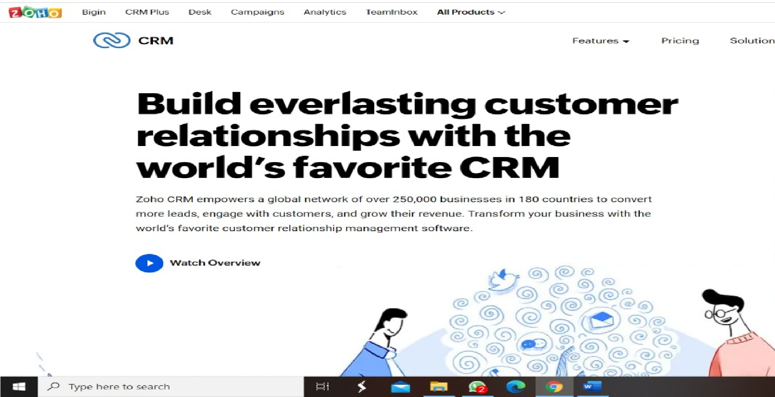

**STEP 2: LOGINTOTHE ZOHO.COM**



**STEP 3: SELECT ONE APPLICATION**

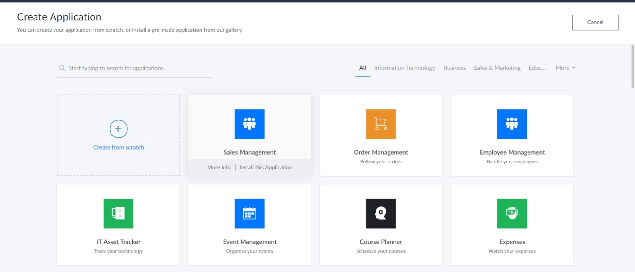

**STEP 4: ENTER APPLICATION NAME**

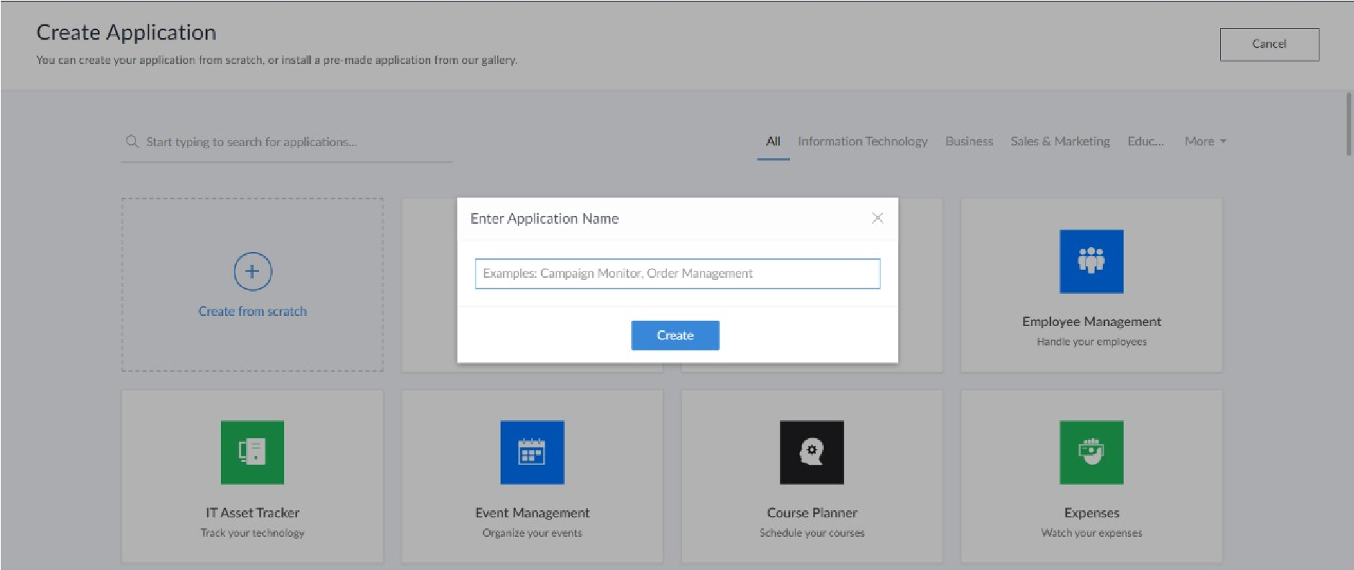

**STEP 5: CREATED NEW APPLICATION**

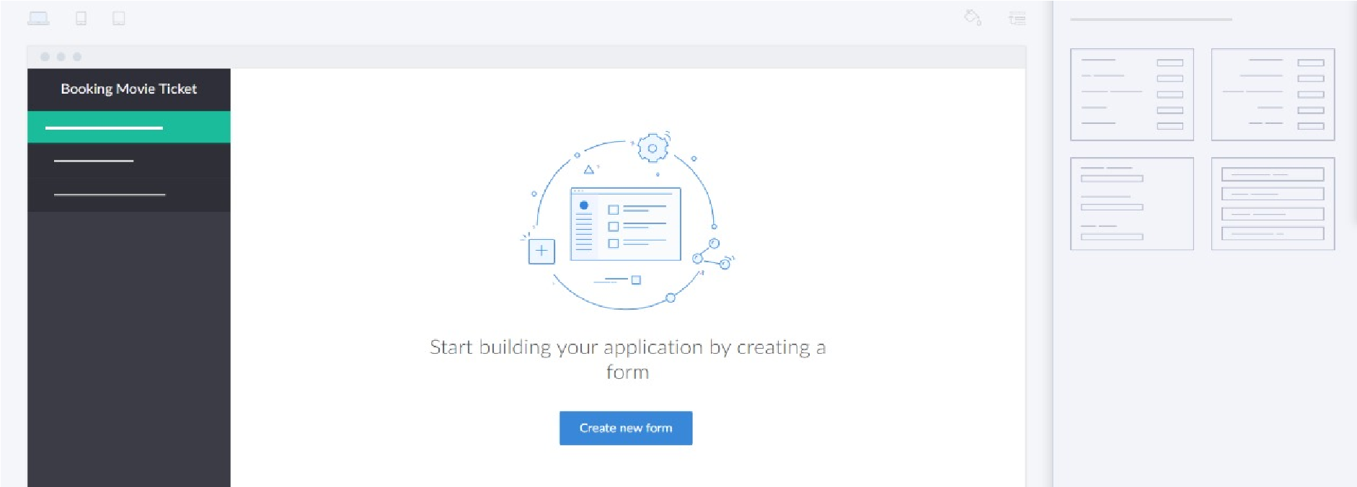

**STEP 6: SELECT ONE FORM**

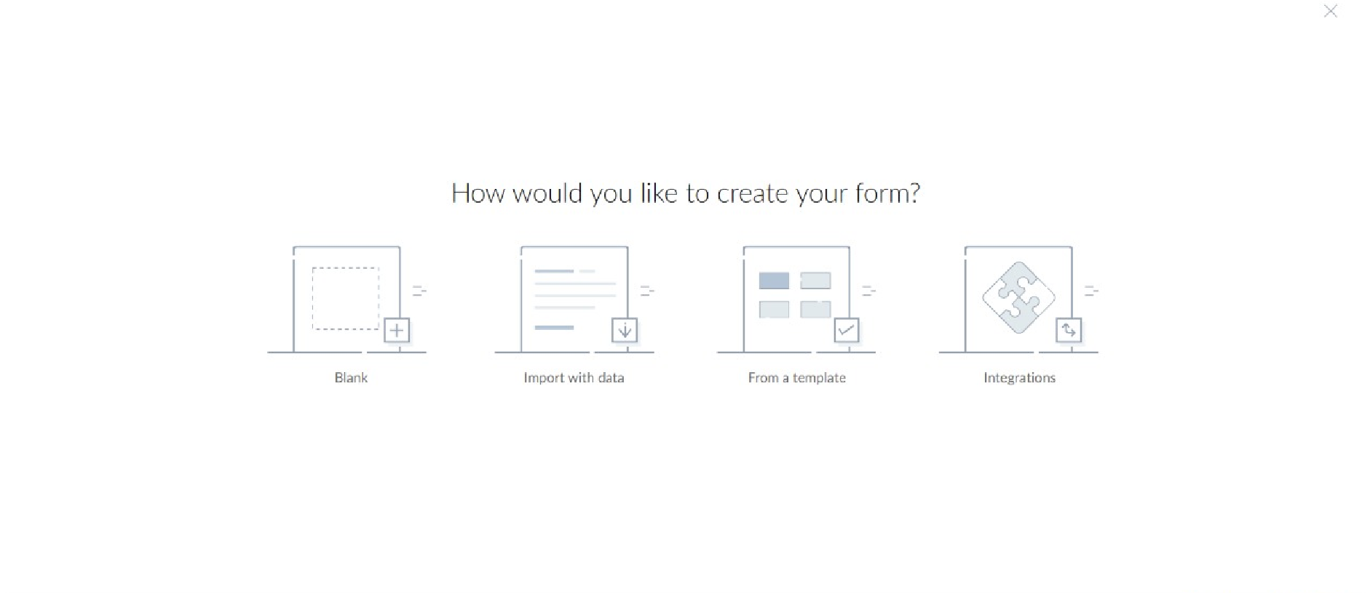

**STEP 7: THE SOFTWARE HASE BEEN CREATED.**

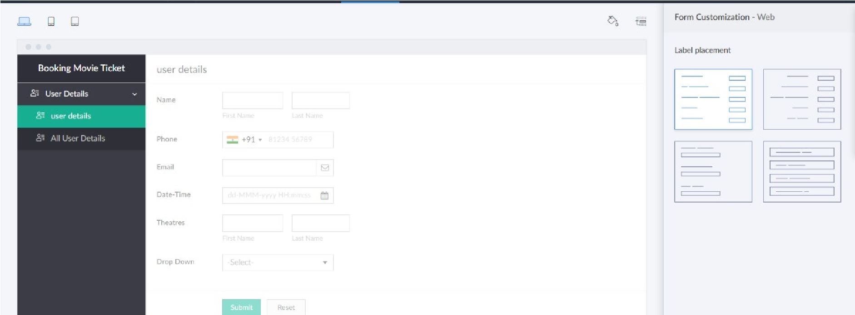

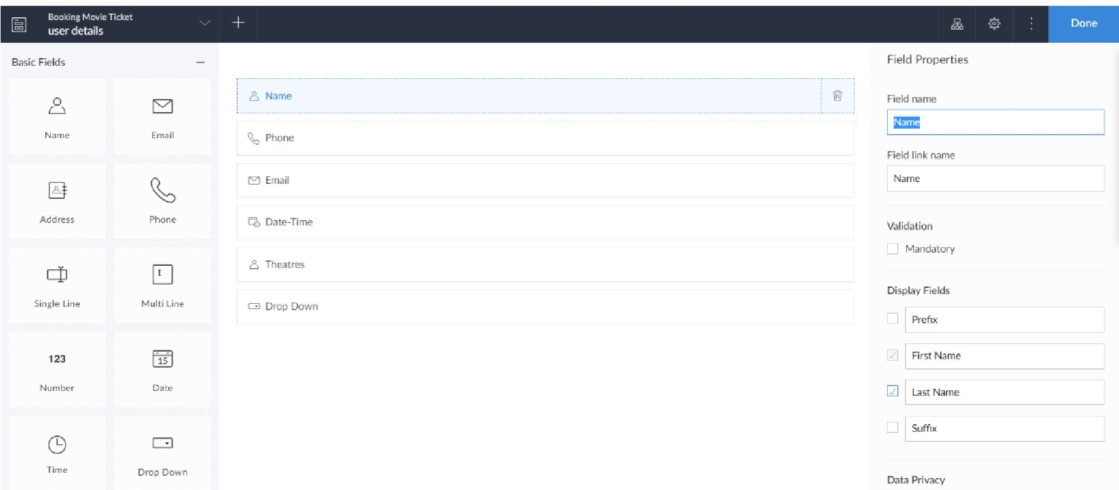

**EXPNO 2: CREATE A VIRTUAL MACHINE WITH 1 VCPU, 2GB RAM AND 15GB**

**STORAGE DISK USING A TYPE 2 VIRTUALIZATION SOFTWARE**

**STEP 1:**

**DOWLOAD VMWARE WORKSTATION AND INSTALLED AS TYPE 2**

**HYPERVISOR**

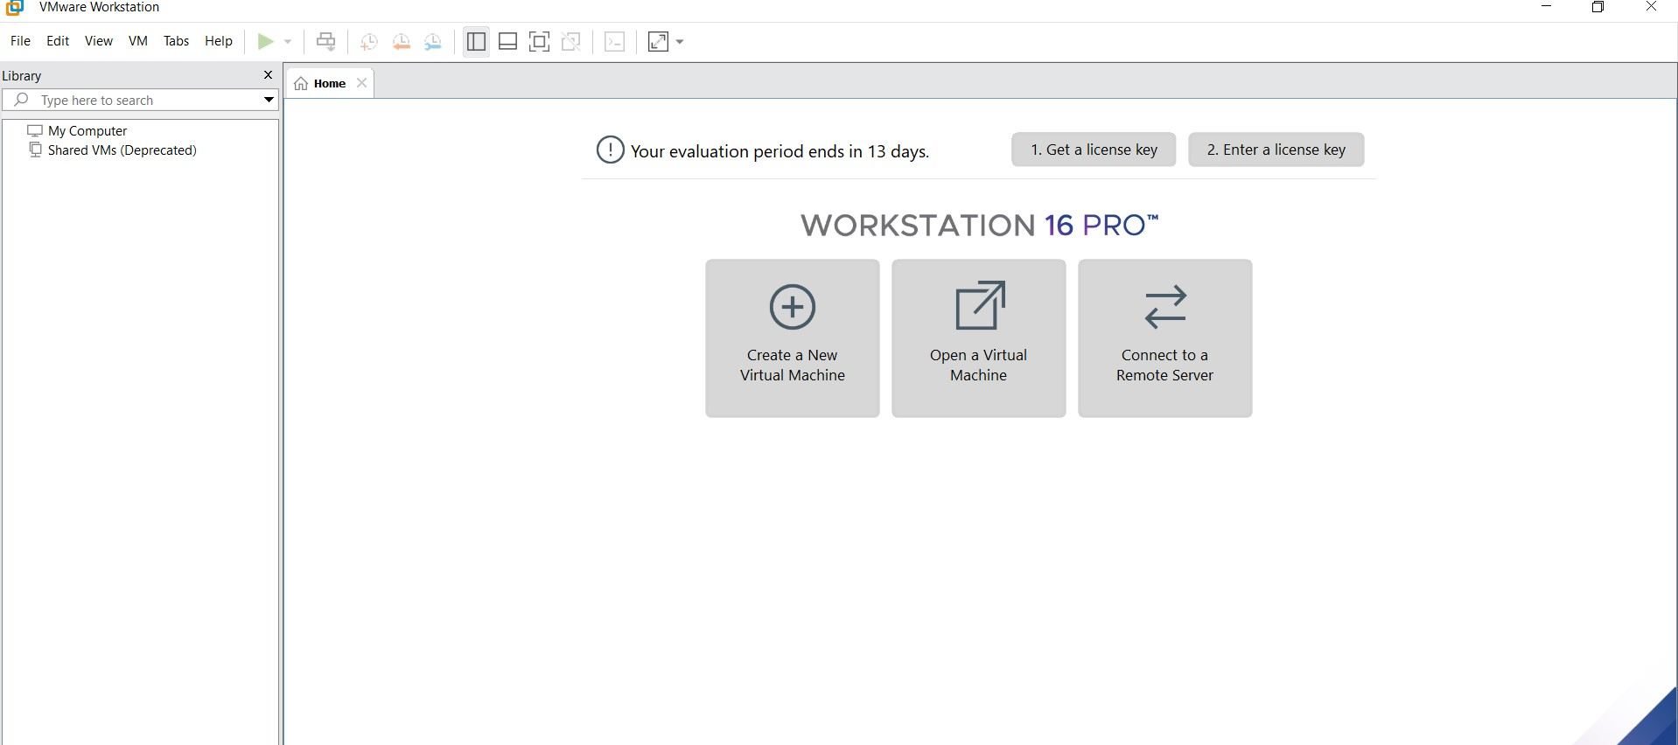

**STEP2: DOWLOAD UBUNTU OR TINY OS AS ISO IMAGE FILE**

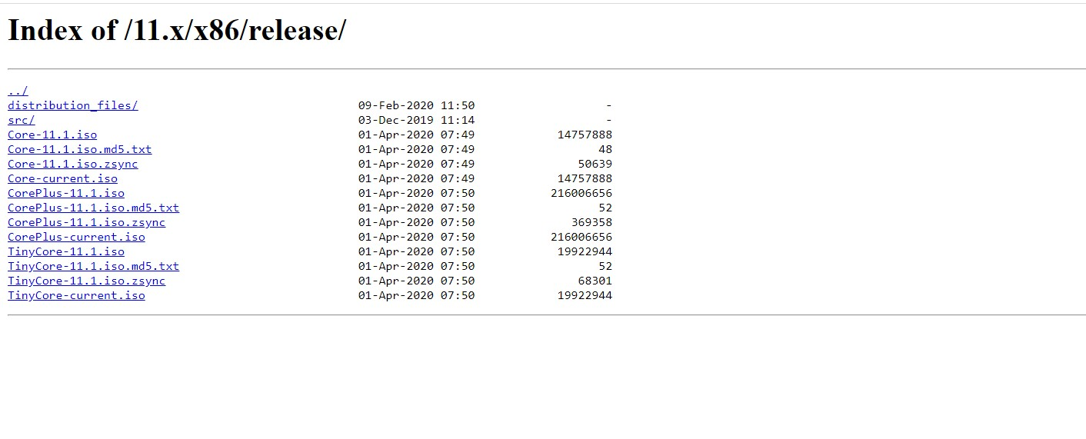

**STEP 3: IN VMWARE WORKSTATION->CREATE NEW VM**



**STEP 4: DO THE BASIC CONFIGURATION SETTINGS.**

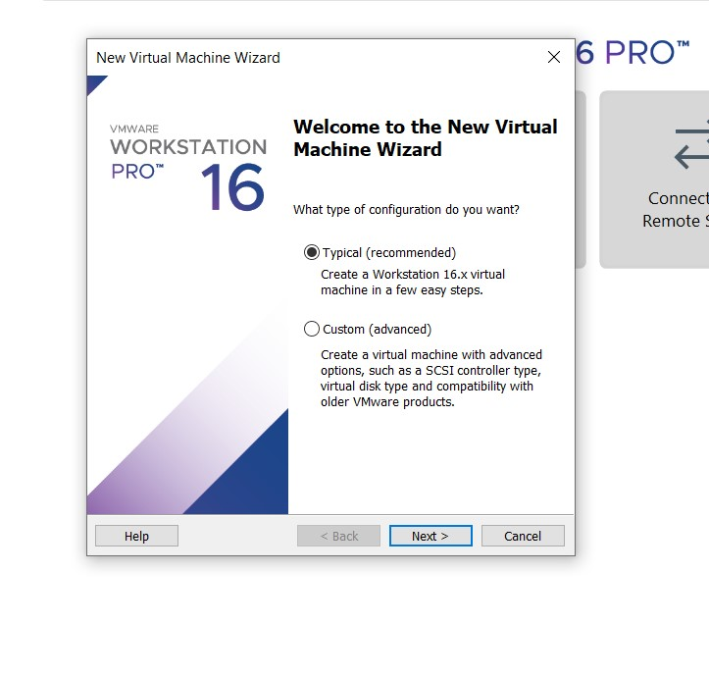

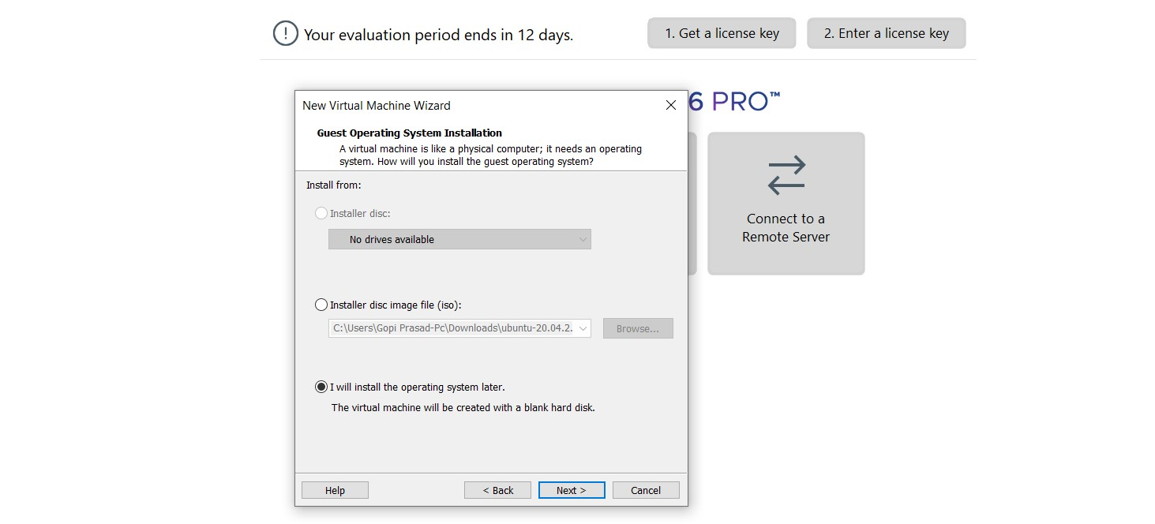

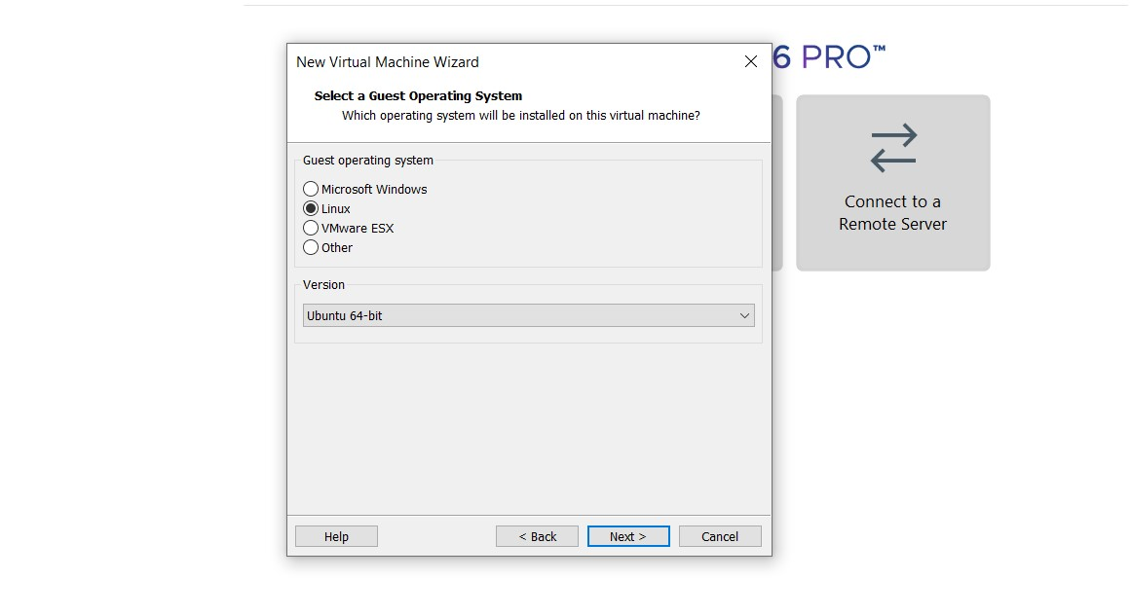

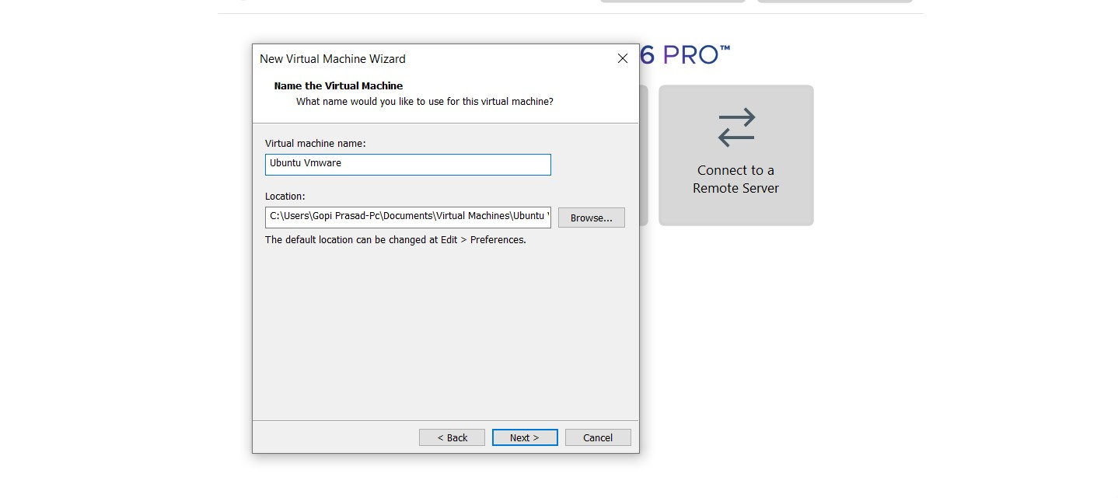

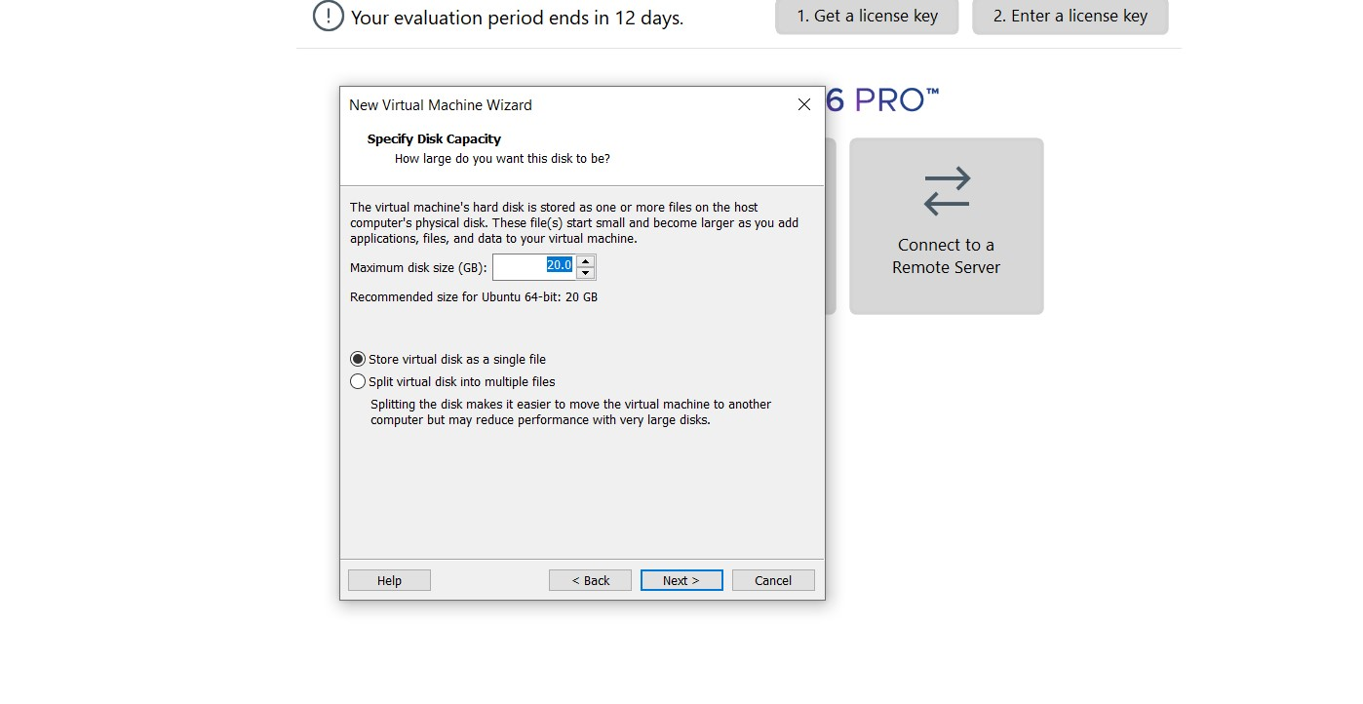



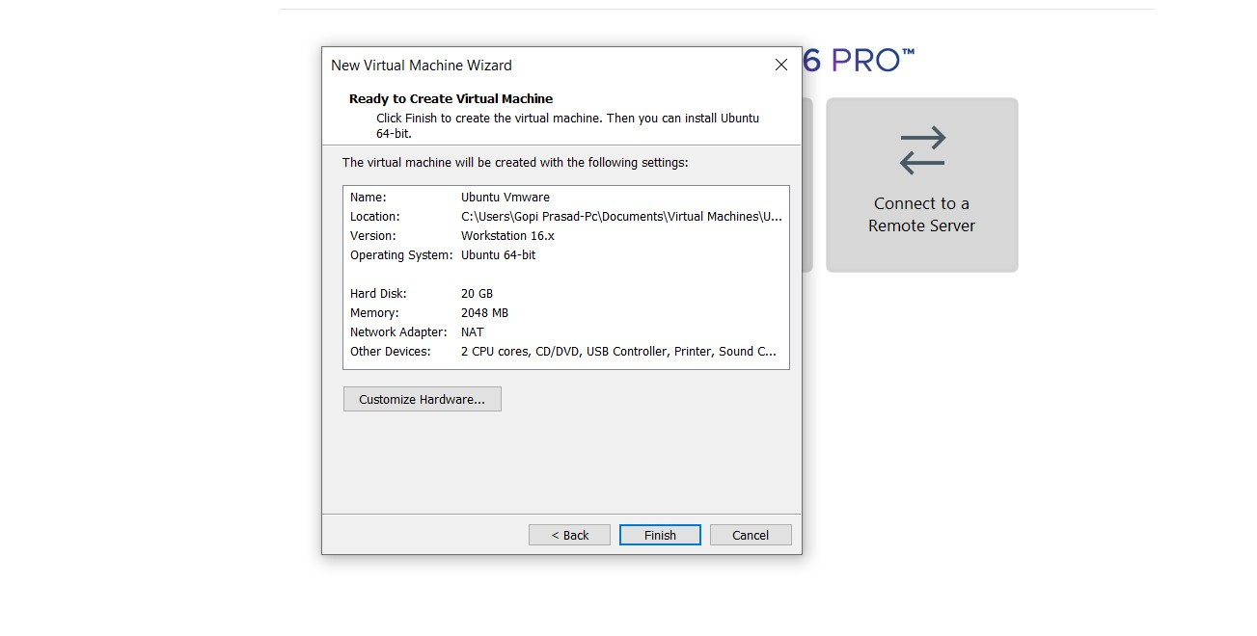

**STEP 4: CREATED TINYOS VIRTUAL MACHINE**

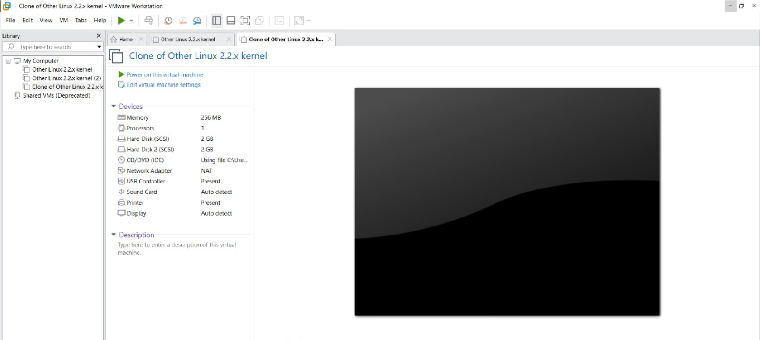

**STEP 5: LAUNCH THE VM**

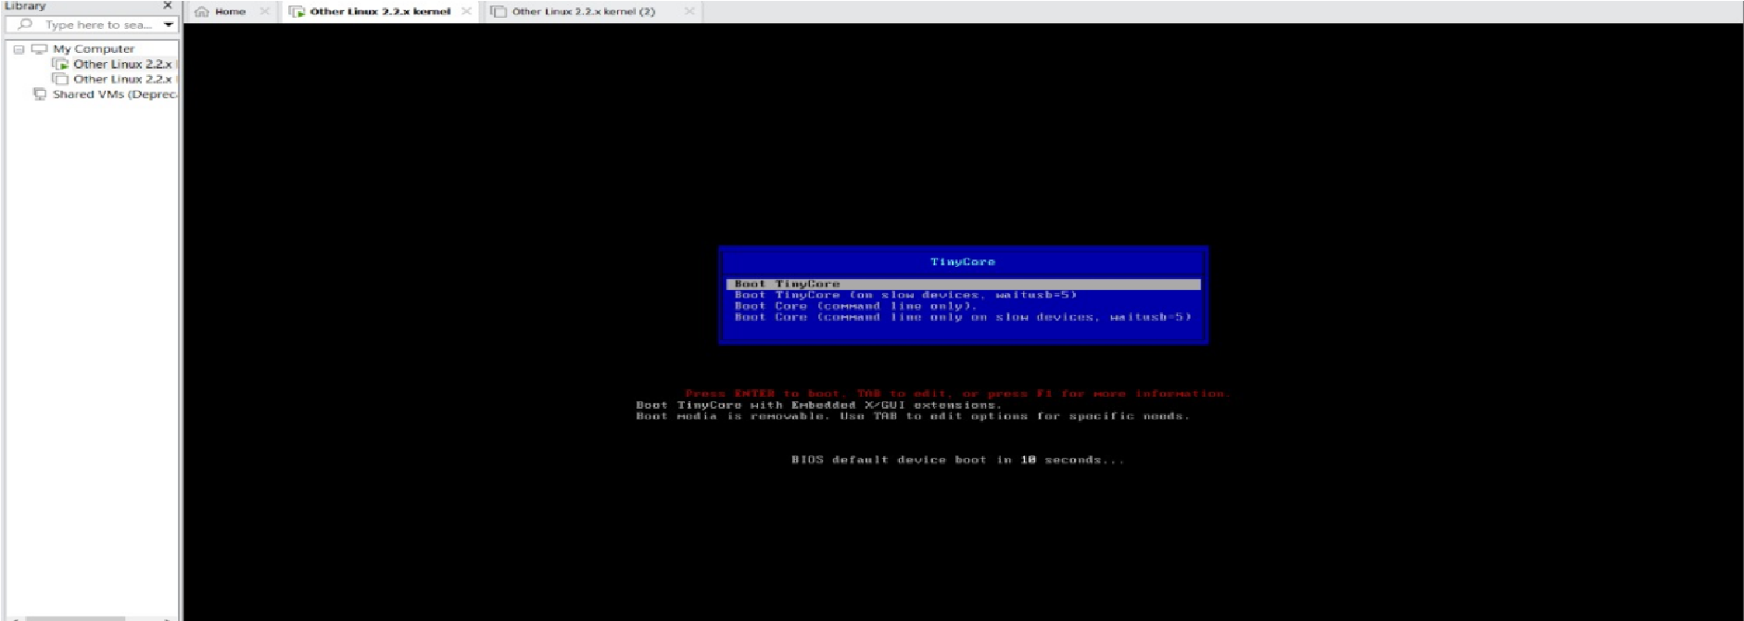

**EXP 3: CREATE A VIRTUAL HARD DISK AND ALLOCATE THE STORAGE**

**USING VM WARE WORKSTATION**

**STEP 1:**

**GOTO VM WARE WORKSTATION**

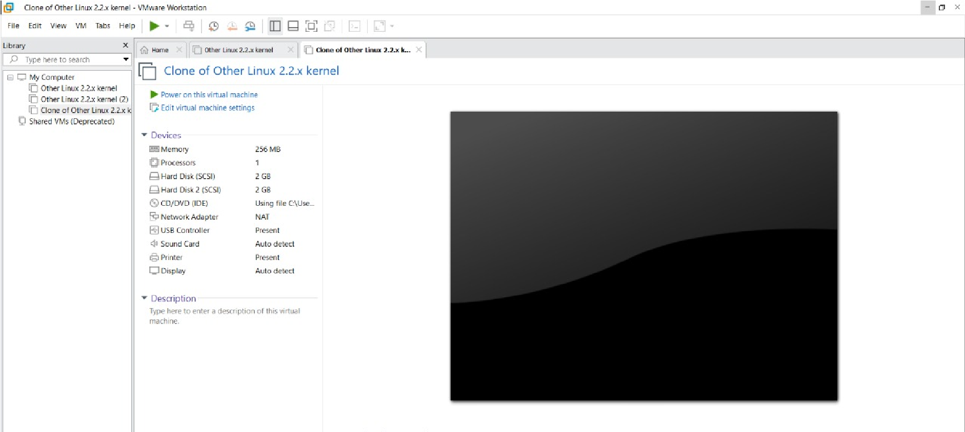

**STEP2: RIGHT CLICK THE VM AND GOTO THE SETTINGS**

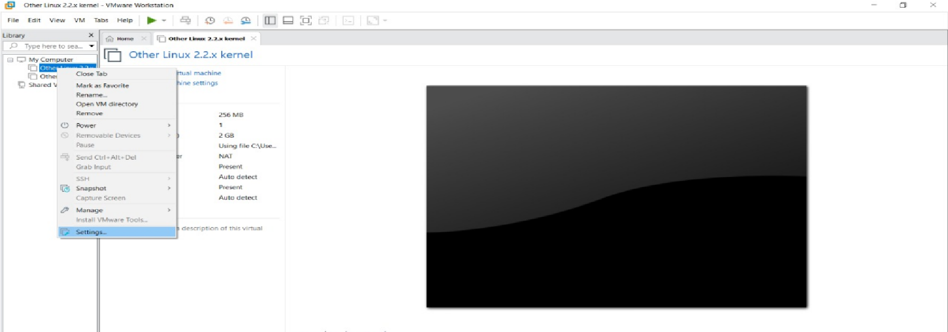

**STEP 3: ADD HARDWARE WIZARD AND SELECT SCSI AND CLICK NEXT**

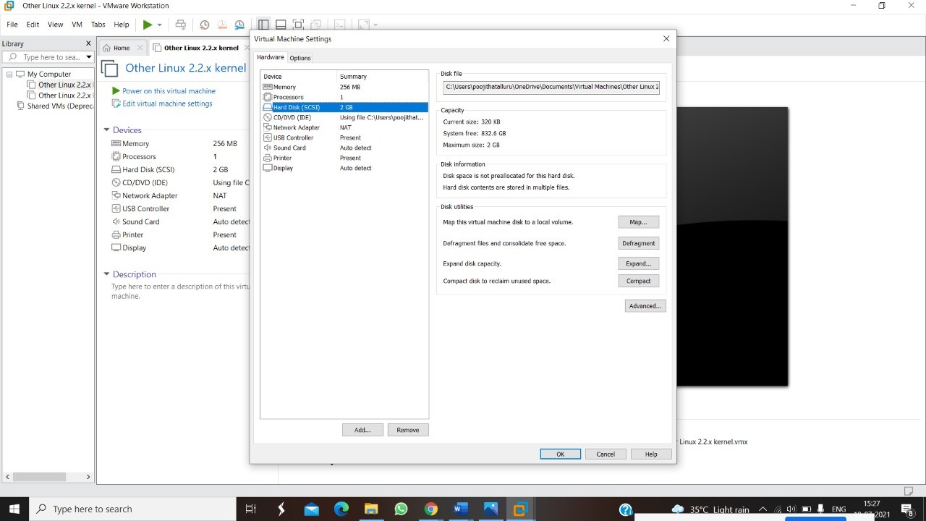

**STEP 4: CREATE NEW VIRTUAL DISK**

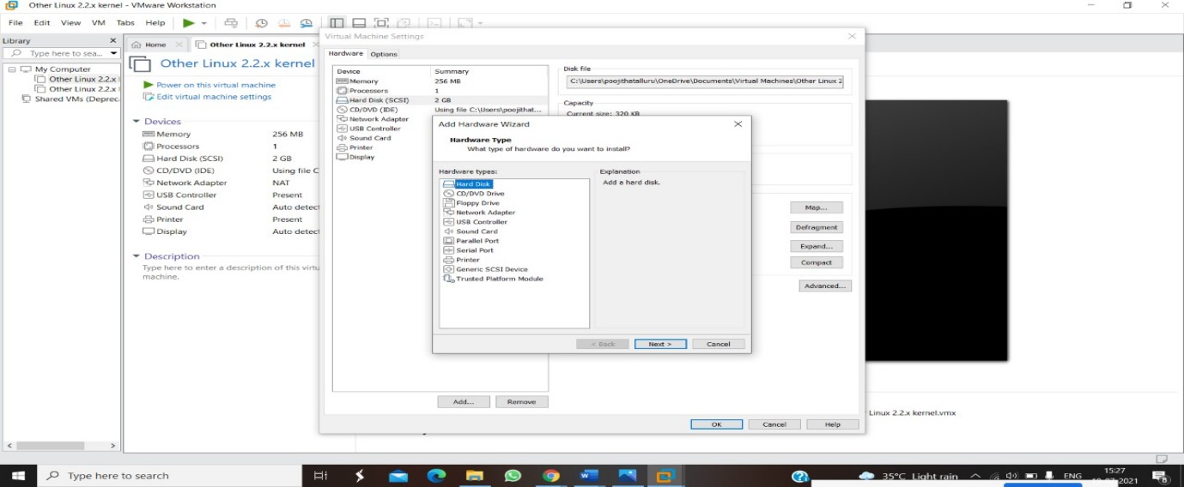

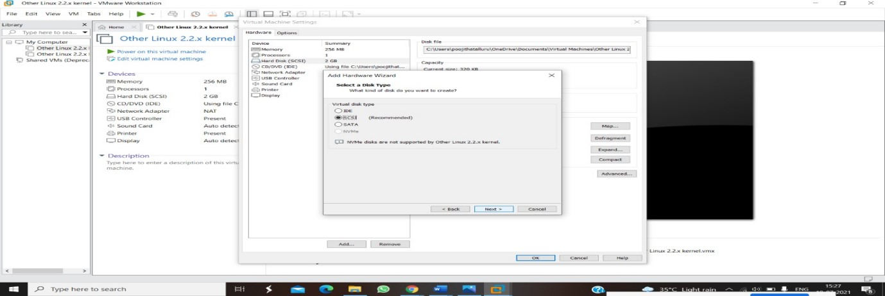

**STEP 5: SELCT THE DISK SIZE AS 2.0. AND SELCT SPLIT VIRTUAL DISK INTO MULTIFILES.**

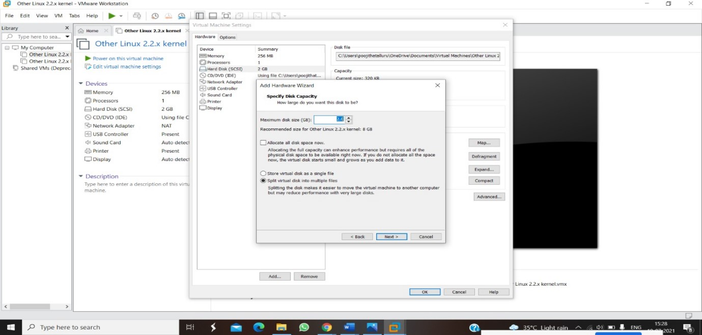

**STEP 6: GIVE NAME AND CLICK THE FINISH**

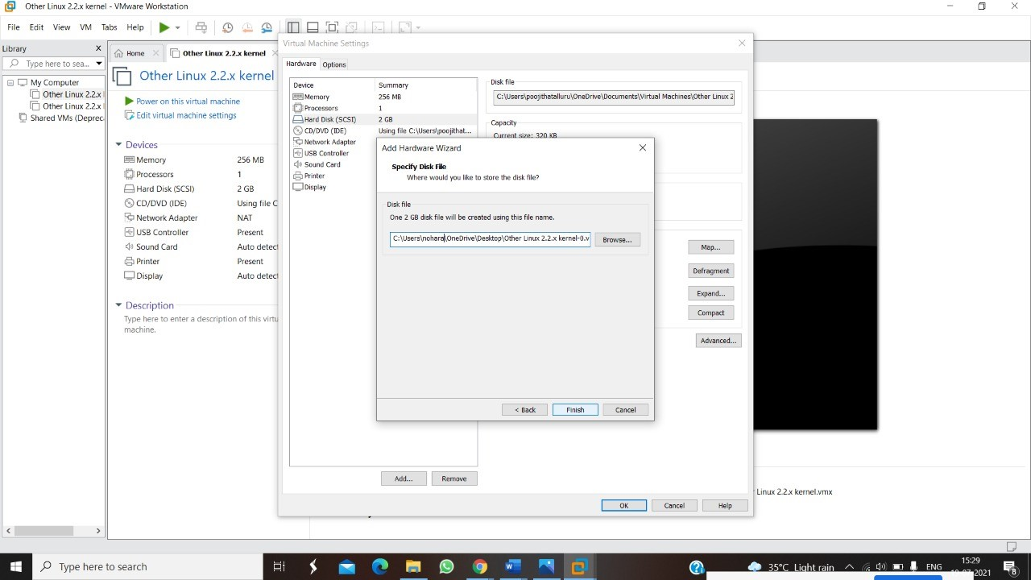

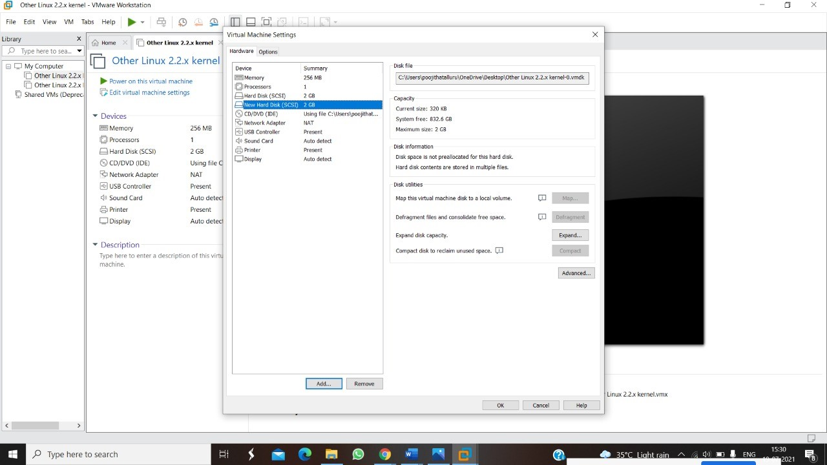

**RESULT:**

**EXPNO 4: CREATE A SNAPSHOT AND CLONING OF A VM AND TEST IT BY**

**LOADING THE PREVIOUS VERSION/CLONED VM**

**STEP 1: GOTO VMWARE WORKSTATION**

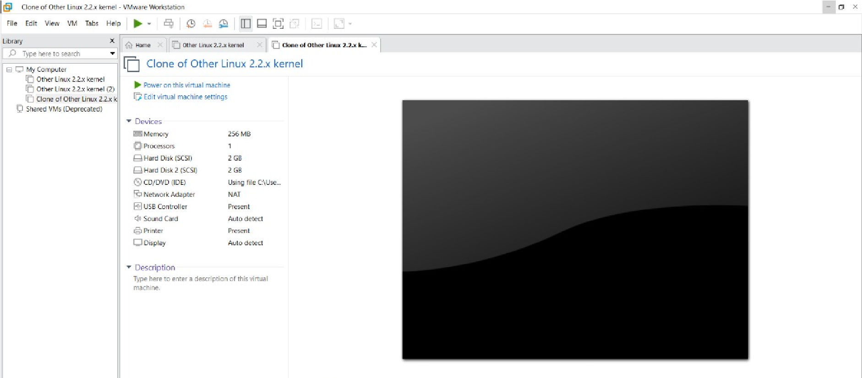

**STEP 2: CREATE FILES ON DESKTOP**

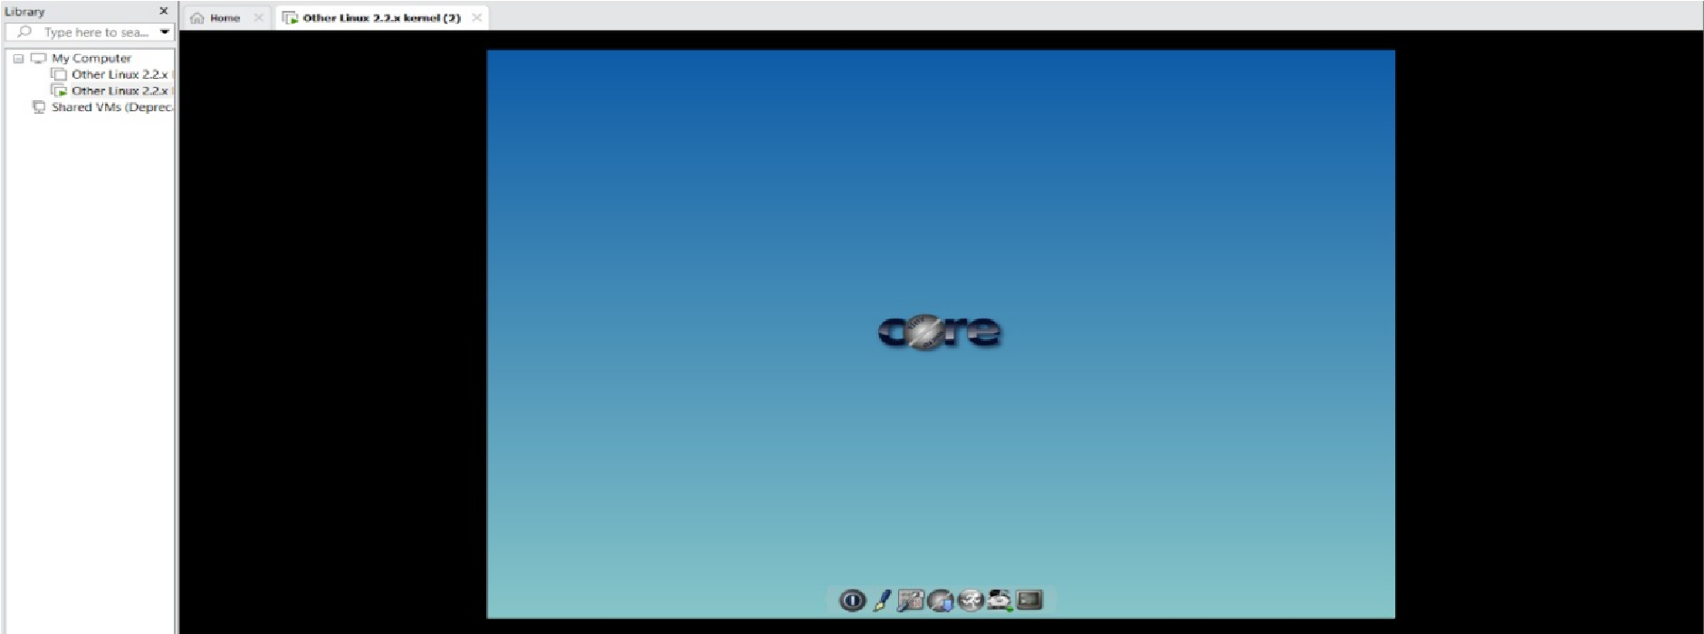

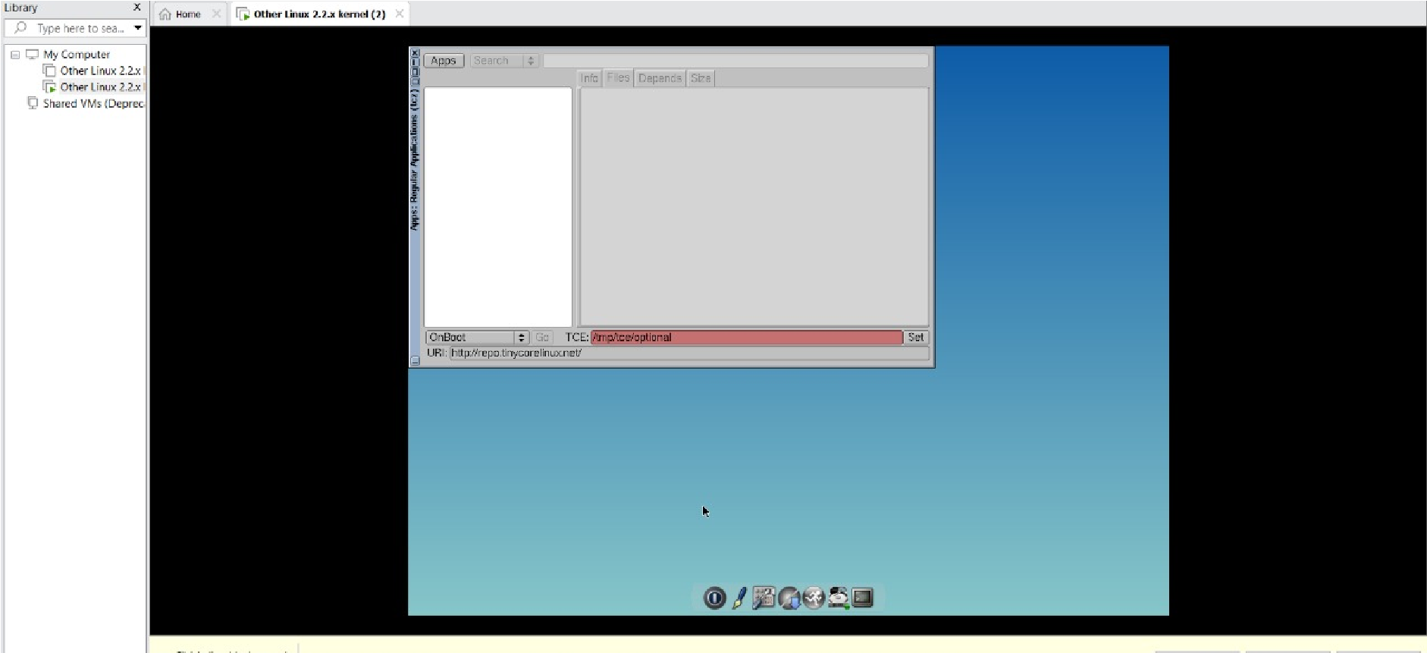

**STEP 2: CLICK ON VM AND SELECTS SNAPSHOT-> TAKE SNAPSHOT.**

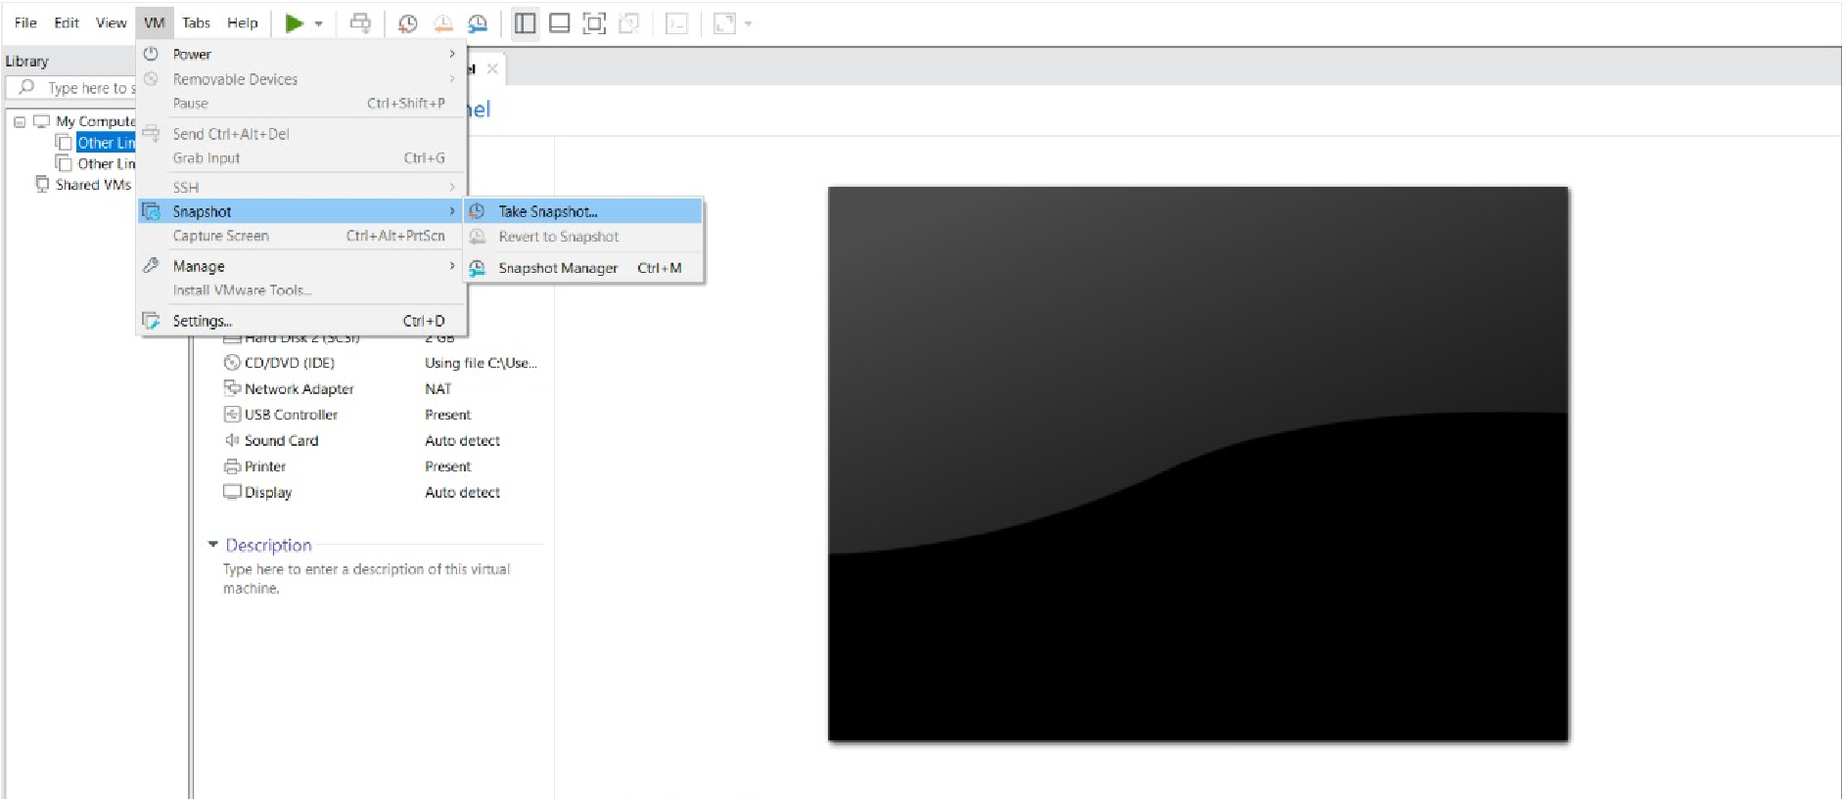

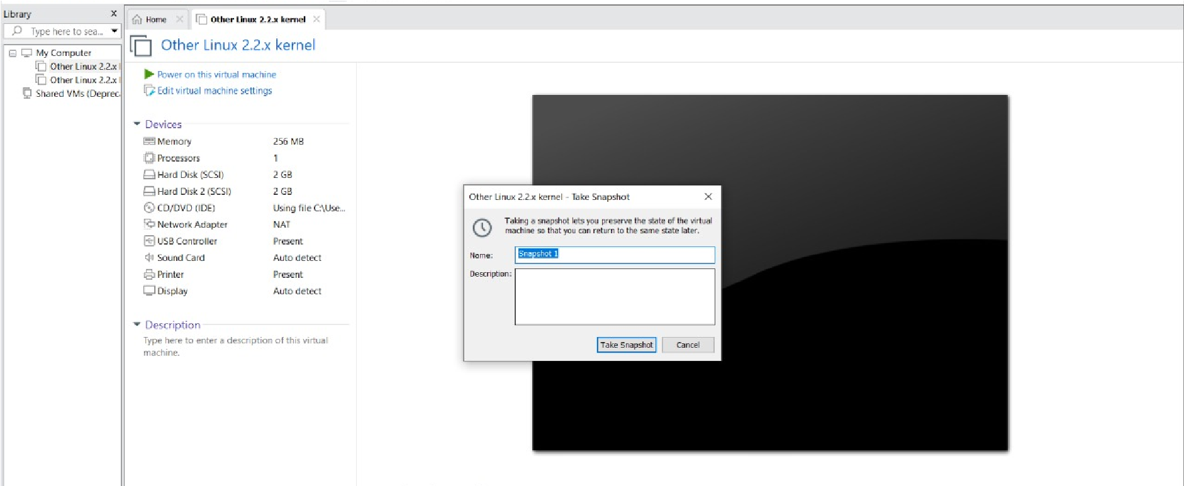

**STEP 4: SNAPSHOT IS BEING DONE**

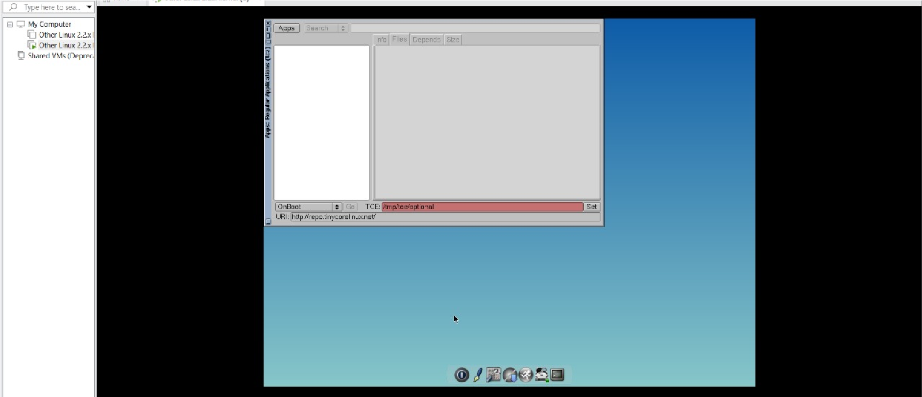

**CLONING OF A VM**

**STEP 1: GO TO VM AND GOTO MANAGE AND CLICK CLONE**

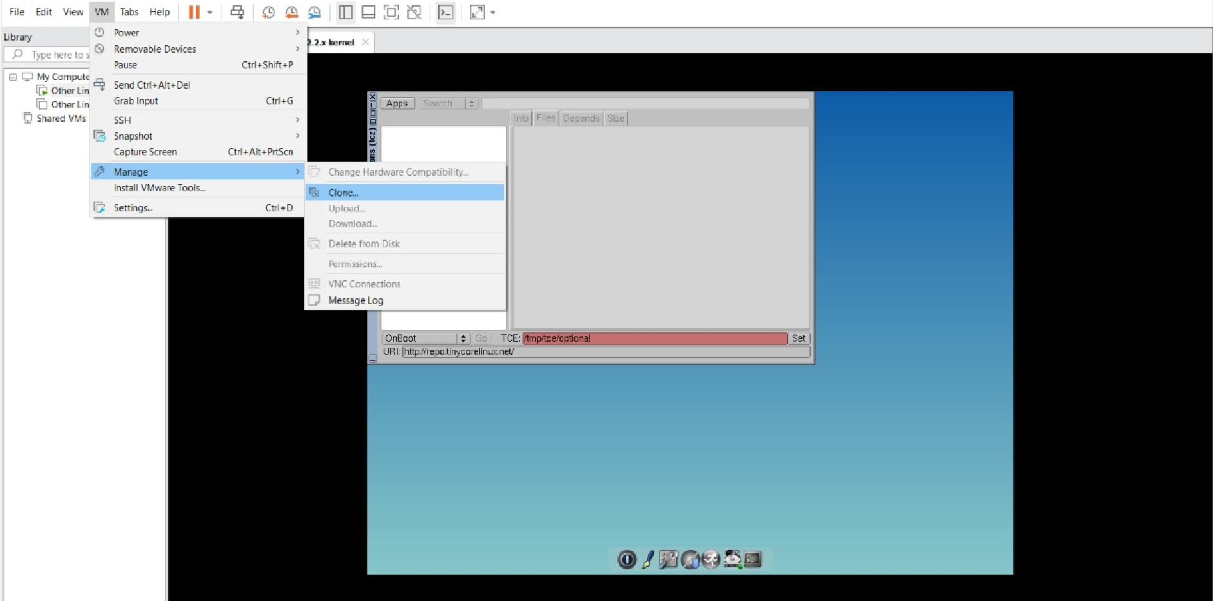

**STEP 2: CLICK CLONE**

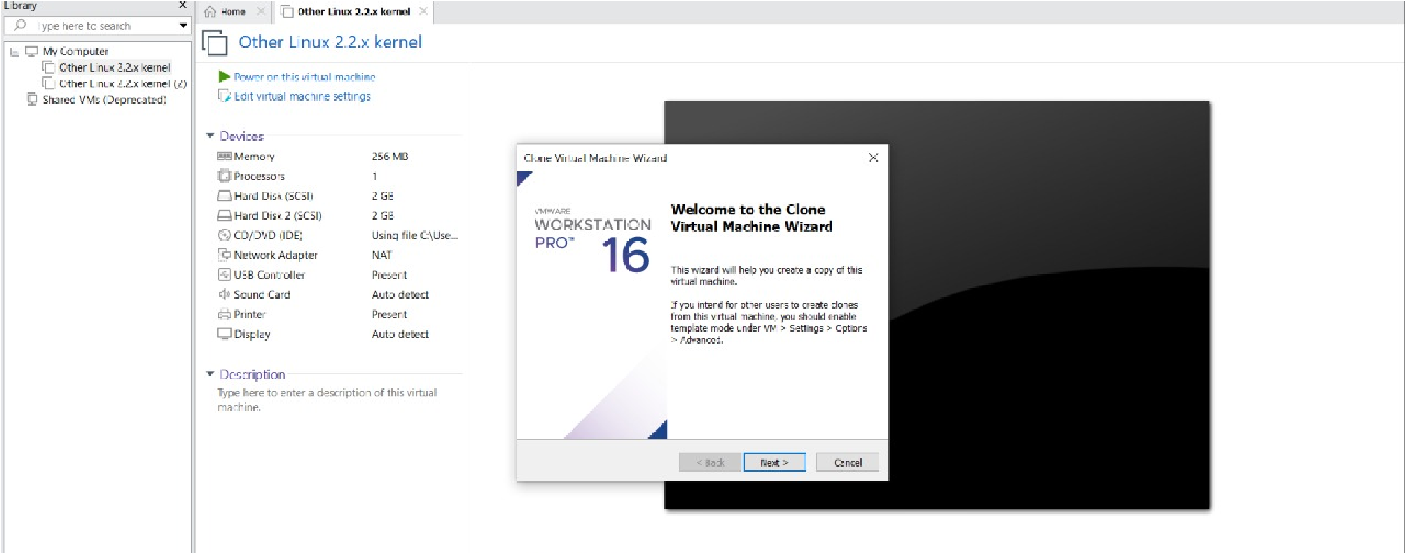

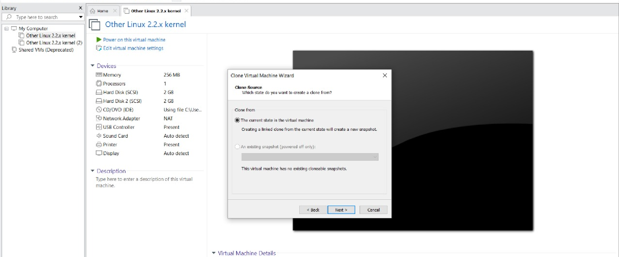

**STEP 3: SELECT THE FULL CLONE**

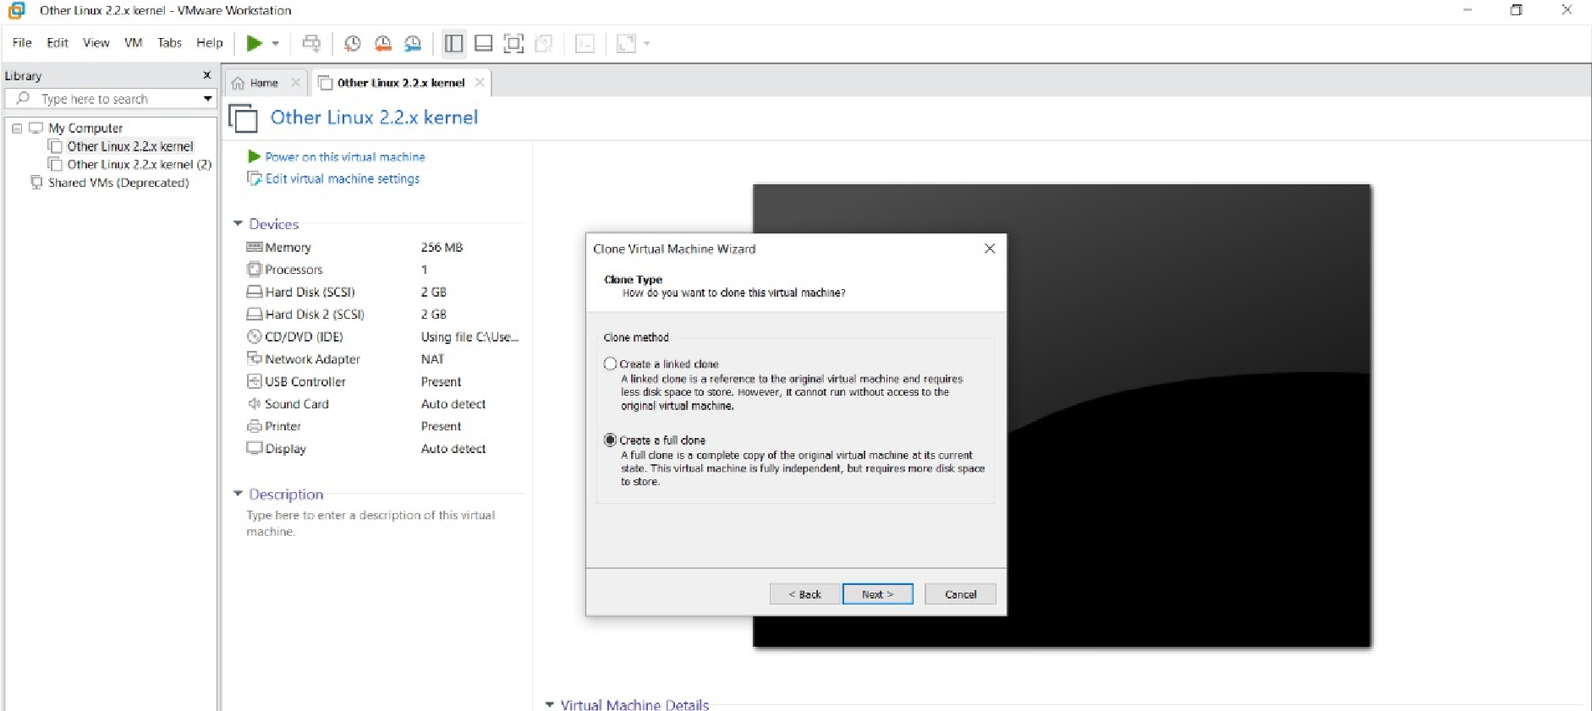

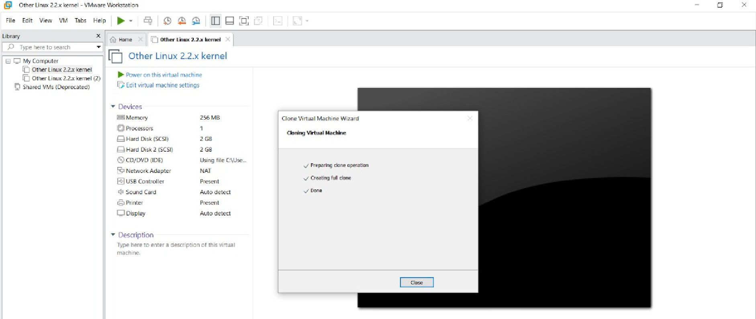

**STEP 4: AFTER CLONE AGAIN OR VM IS OPENED.**

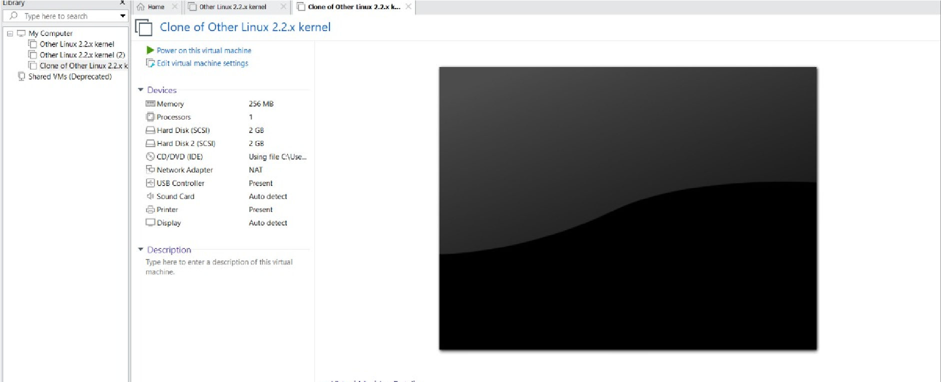

**5.DEMONSTRATE INFRASTRUCTURE AS A SERVICE(IAAS) BY CREATING A VIRTUAL MACHINE USING A PUBLIC CLOUD SERVICE**

**PROVIDER(AZURE/GCP/AWS) CONFIGURE WITH MINIMUM CPU,RAM AND STORAGE AND LAUNCH THE VM IMAGE.**

**STEP1:CREATE AN ACCOUNT IN MICROSOFT AZURE.**

**STEP2: GOTO RESOURCE GROUP AND CREATE A RESOURCE GROUP.**

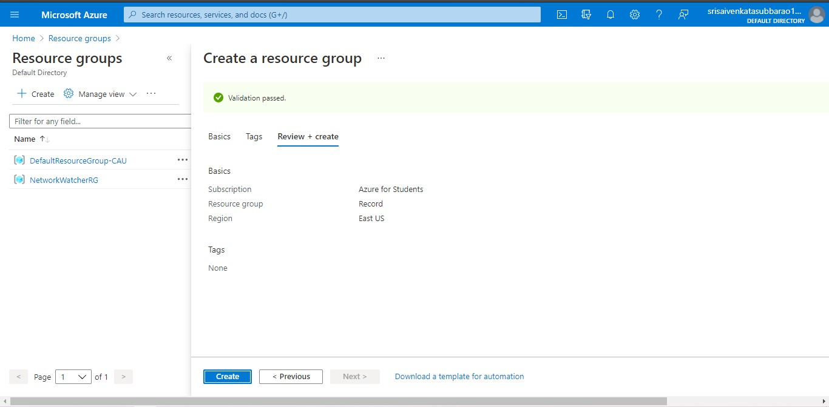

**STEP3: GIVE NECESSARY THINGS FOR RESOURCE GROUP.**

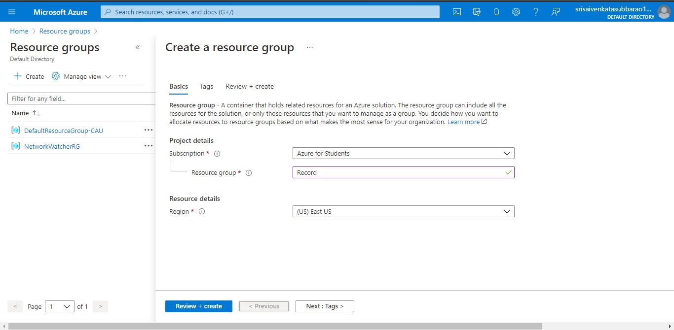

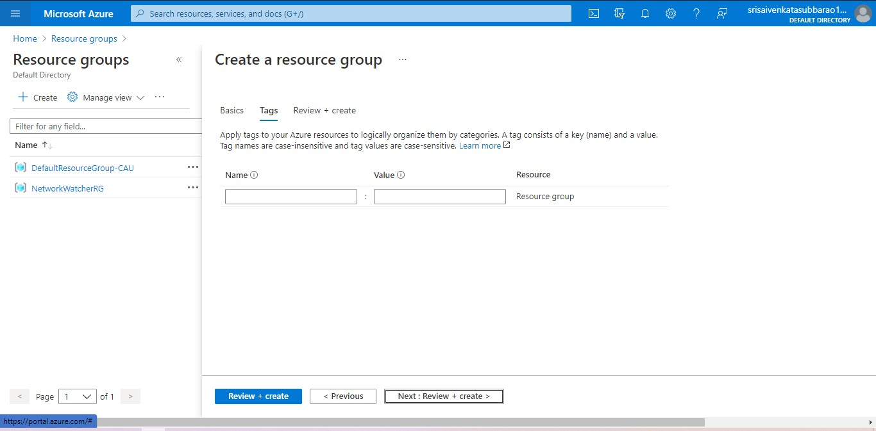

**STEP4: CREATE A VIRTUAL NETWORK FOR TO CREATE A VIRTUAL MACHINE .**

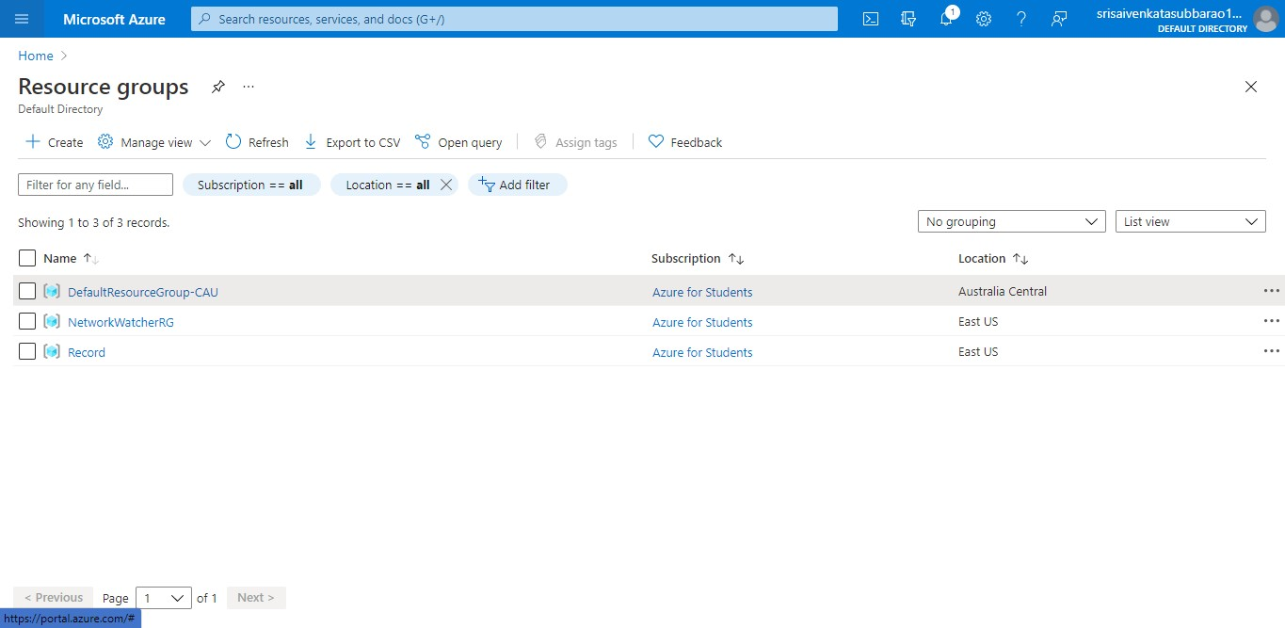

**STEP5: NOW CREATE A VIRTUAL MACHINE WITH UR IP ADDRESS AN USERNAME AND PASSWORD FOR YOUR VIRTUAL MACINE.**

**STEP6: AND YOUR VIRTUAL MACHINE IS DEPLOYED.**

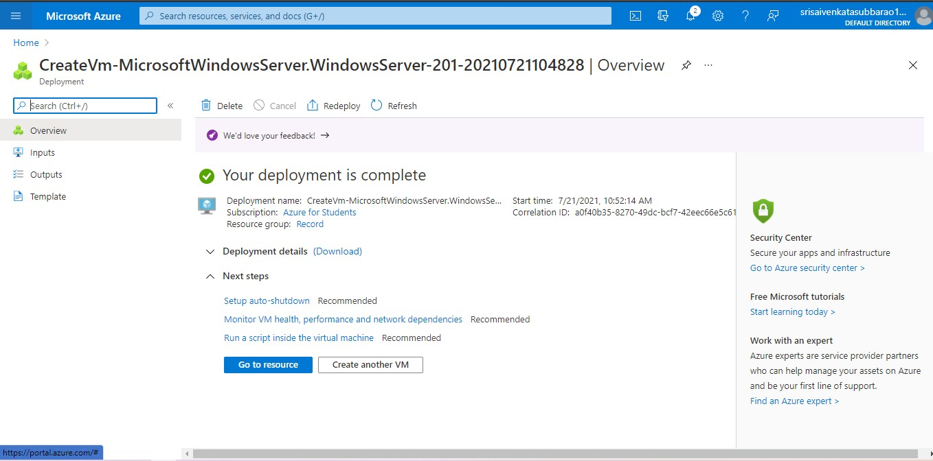

**STEP7: NOW CONNECT THE VIRTUAL MACHINE AND DOWNLOAD THE RDP FILE TO OPEN YOUR WINDOWS VIRTUAL MACHINE.**

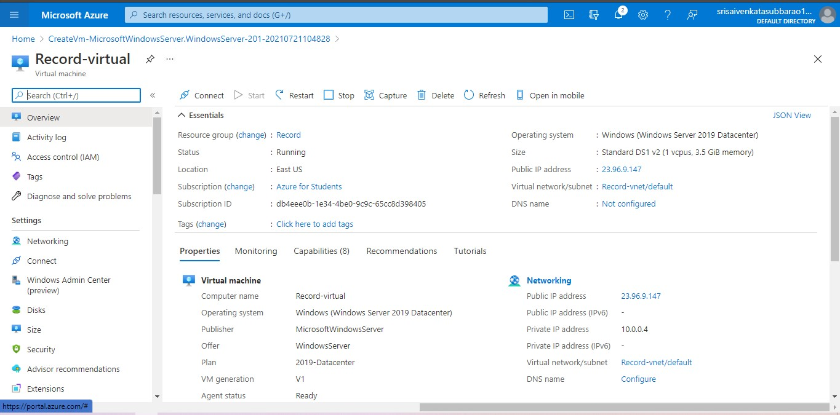

**STEP8: CREATED A NEW WINDOWS VIRTUAL MACHINE.**

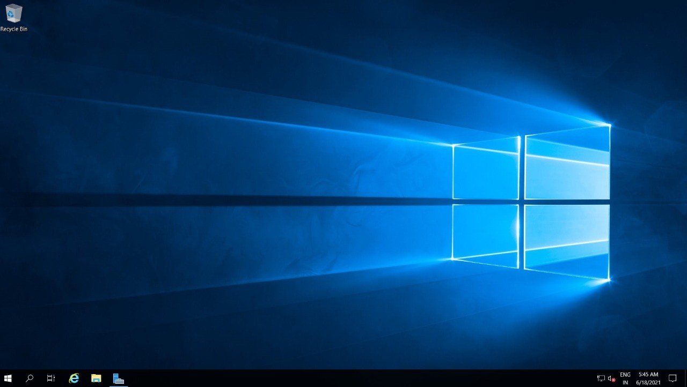

**6.CREATE A SIMPLE WEB SITE USING ANY PUBLIC CLOUD SERVICE**

**PROVIDER (AZURE/GCP/AWS) AND CHECK THE PUBLIC ACCESSIBILITY OF**

**THE STORED FILE TO DEMONSTRATE STORAGE AS A SERVICE**

**STEP1: FIRSTLY GO TO APPSERVICE TO CREATE AN WEBAPP.**

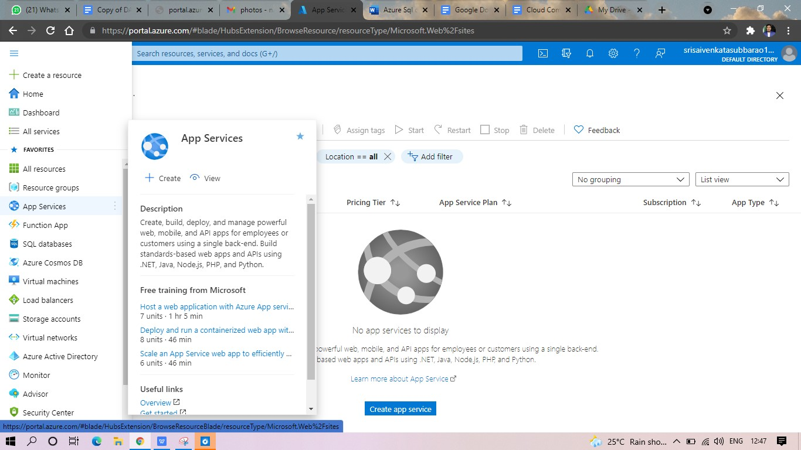

**STEP2: ENTER THE RESOURCE GROUP AND WEBAPP NAME AND REGION AND SELECT THE LINUX OS.**

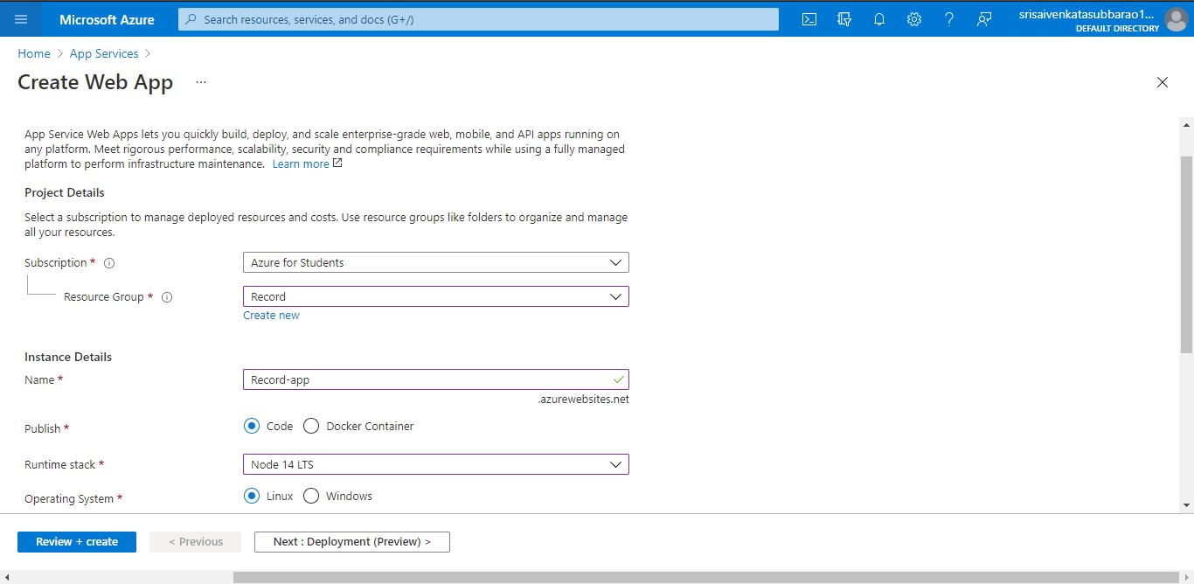

**STEP3: AFTER ENTER THE ALL THE NECESSARY THINGS CLICK THE REVIEW AND CREATE AND CLICK THE CREATE THE WEB APP.**

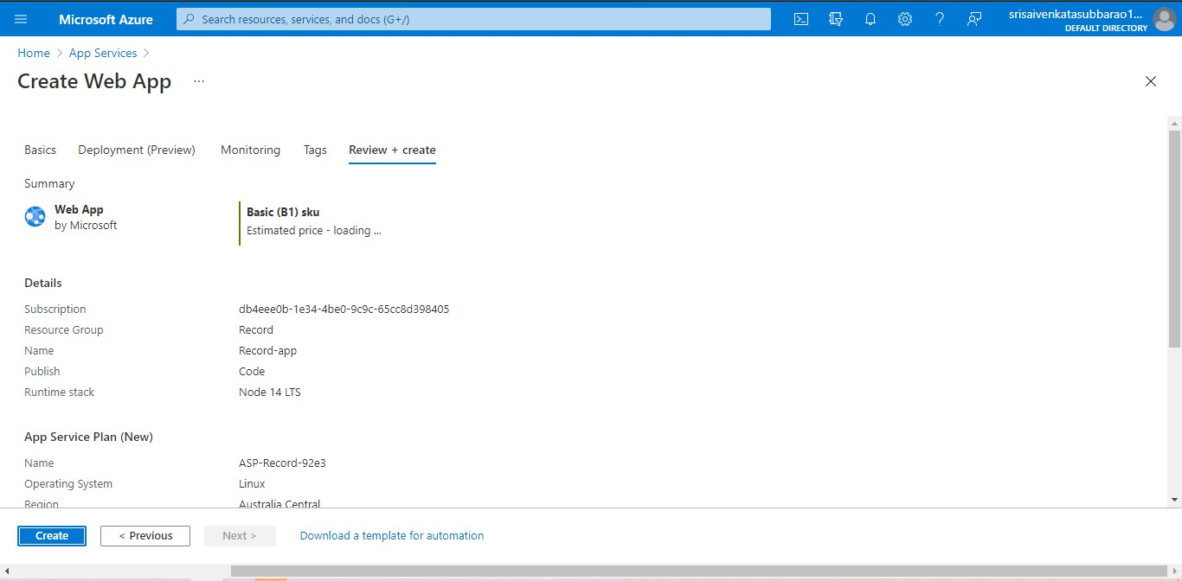

**STEP4: AND OUR DEPLOYMENT IS COMPLETED.**

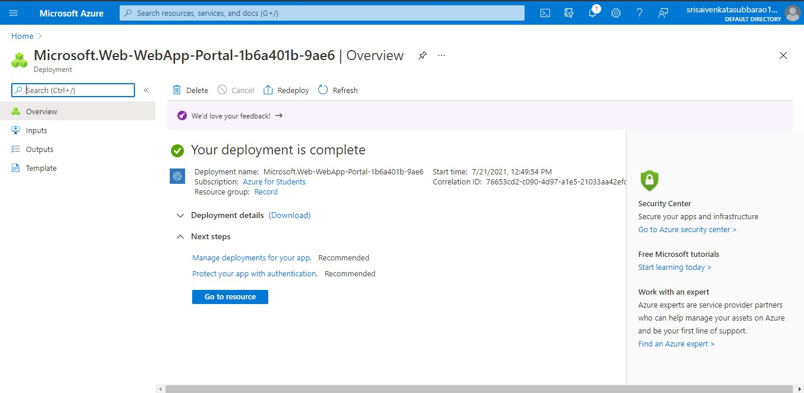

**STEP5: GOTO WEBSITE URL LINK.**

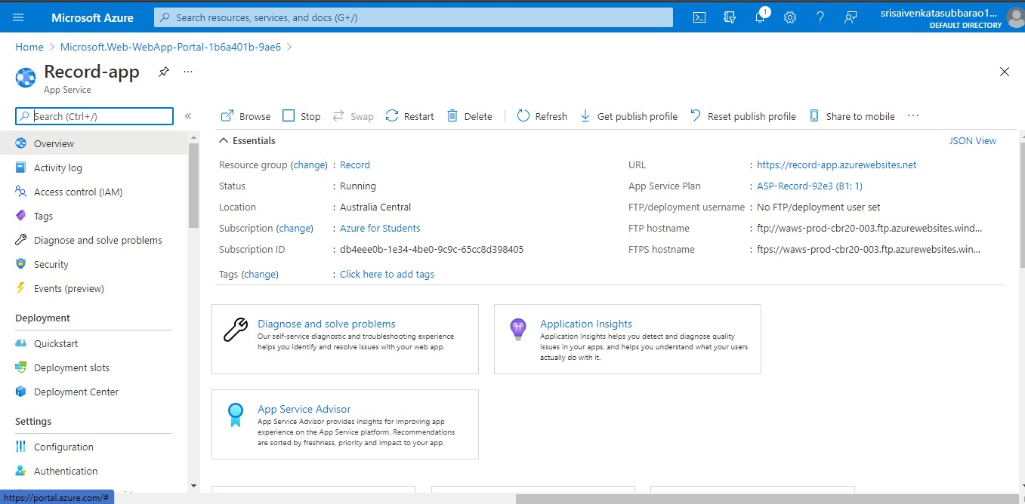

**STEP6: THIS IS OUR WEBAPP SERVICE.**

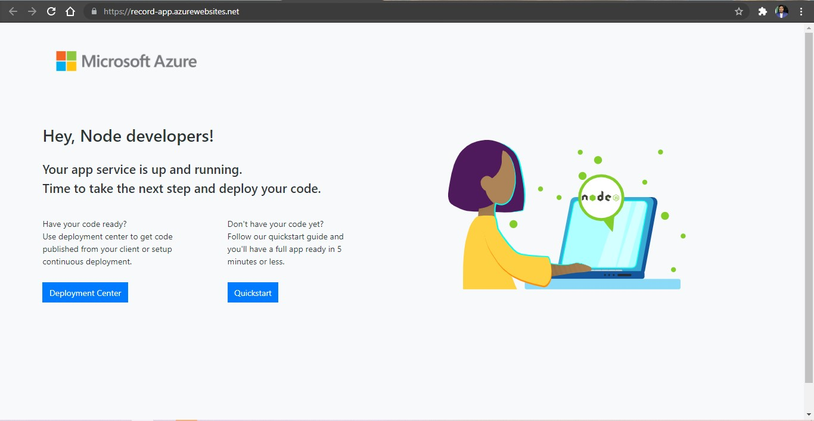

**7.CREATE A STORAGE SERVICE USING ANY PUBLIC CLOUD SERVICE PROVIDER (AZURE/GCP/AWS) AND CHECK THE PUBLIC ACCESSIBILITY OF THE STORED FILE TO DEMONSTRATE STORAGE AS A SERVICE.**

**STEP1: OPEN AZURE AND GOTO STORAGE ACCOUNTS AND CREATE**

**STOROAGE ACCOUNT**

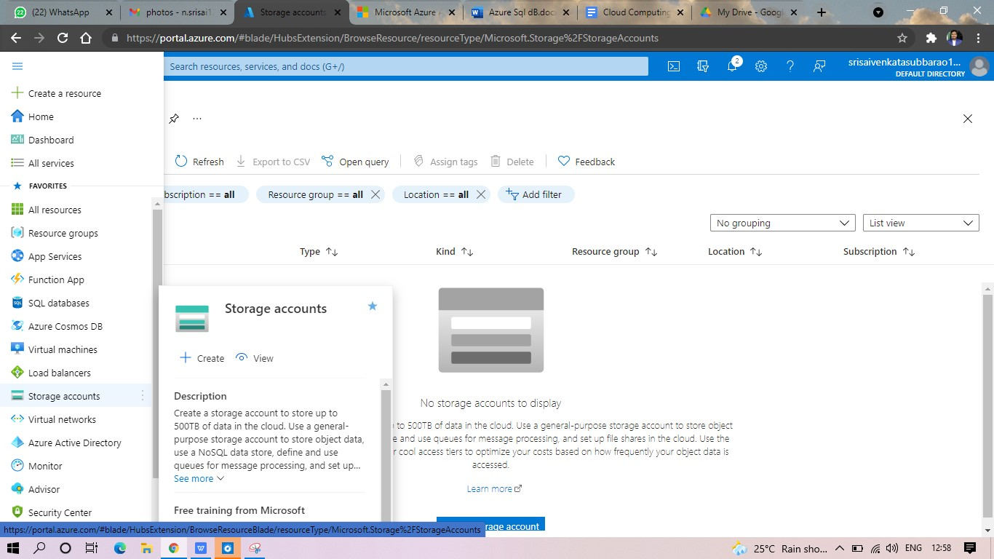

**STEP2: ENTER THE RESOURC GROUP AND AND STORAGE ACCOUNT NAME AND REVIEW AND CREATE AND CLICK TH CREATE AND YOUR STORAGE ACCOUNT WILL BE DEPLOYED SUCESSFULLY.**

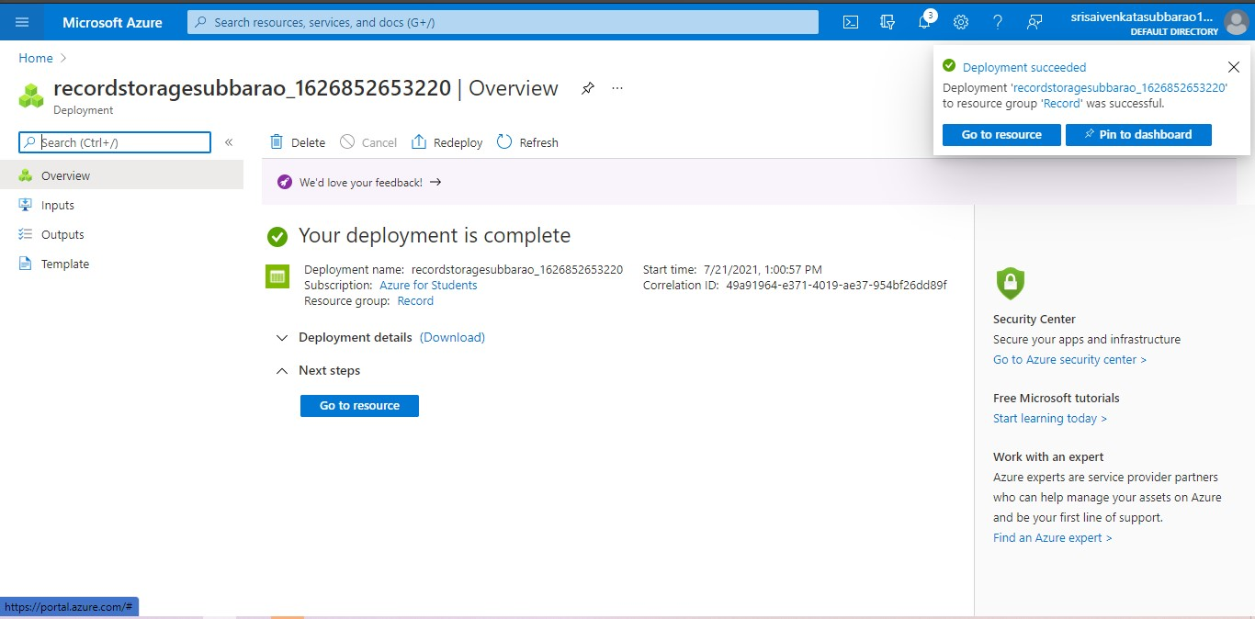

**STP3: AND OUR STORAGE ACCOUNT IS CREATED.**

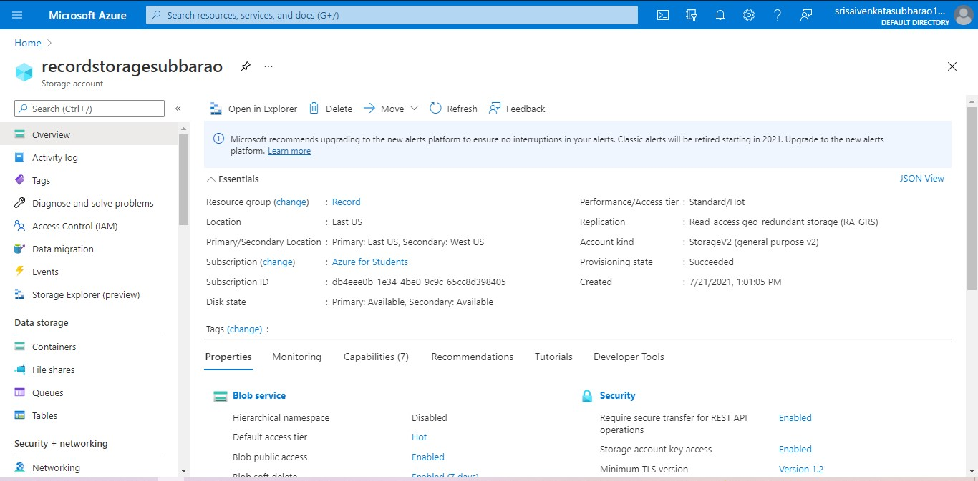

**STEP5: GOTO STATIC WEBSITE**

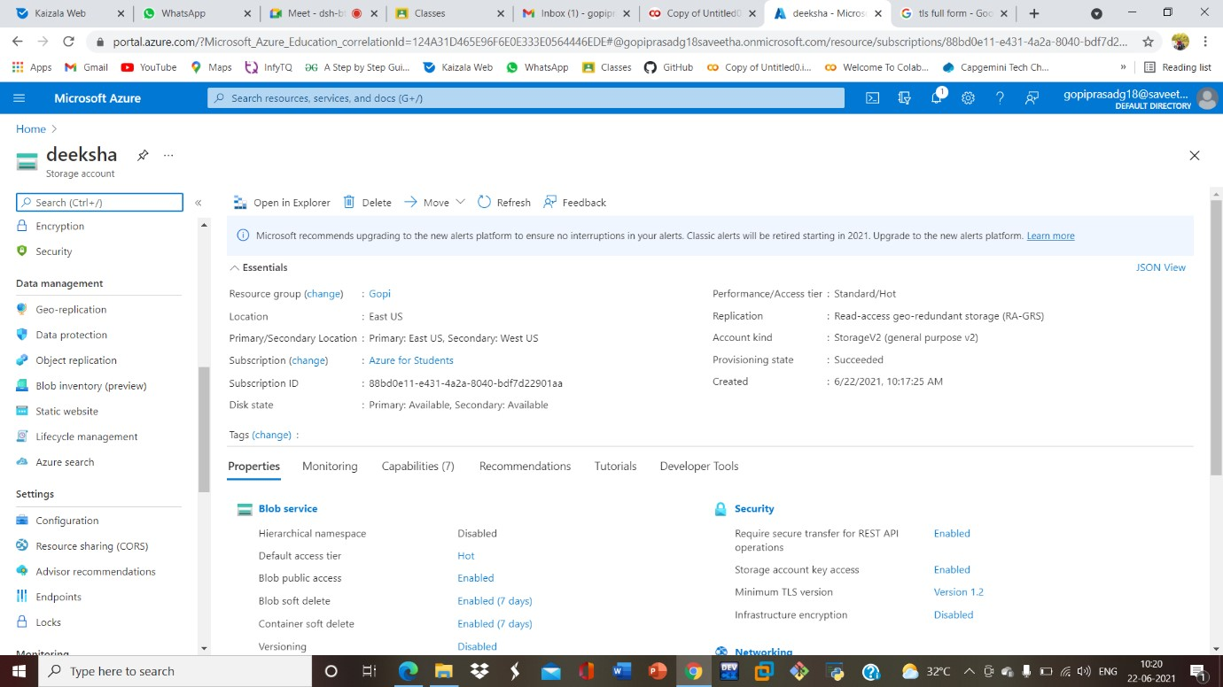

**STEP6: AND ENABLE AND ENTER YOUR INDEX AND ERROR HTML FILESNAMES.**

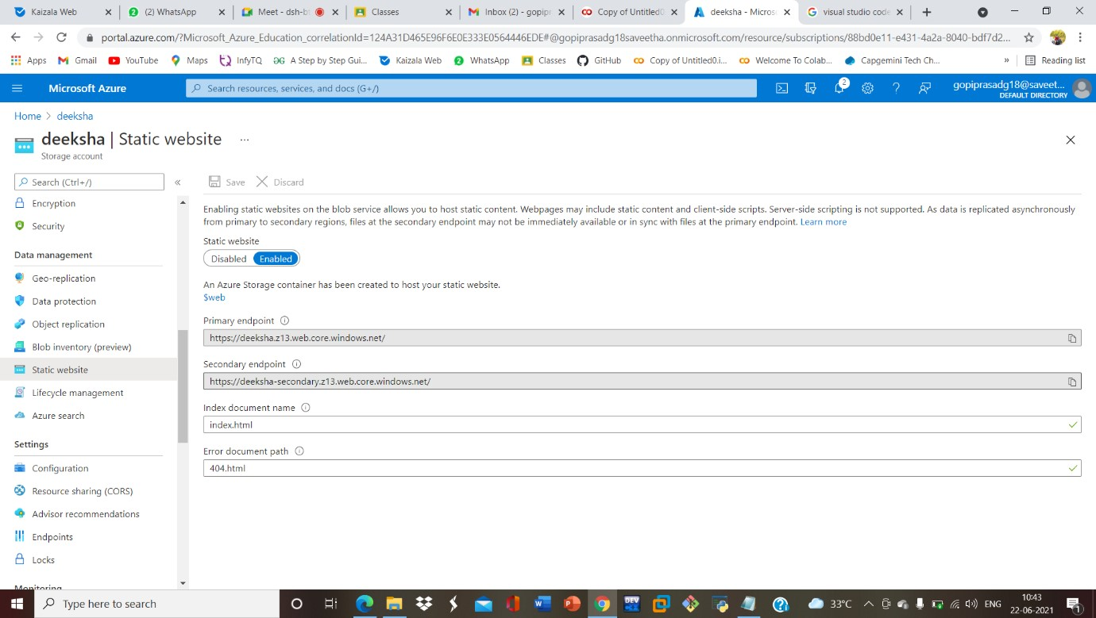

**STEP7: AND GOTO STORAGE EXPLORR(REVIEW) AND AND GOTO BLOB**

**CONTAINERS AND WEB AND UPLOAD THE TWO HTML FILES INIT**

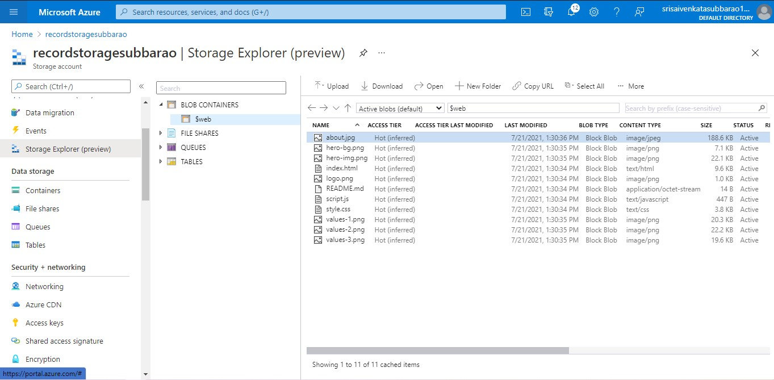

**STEP8: AND AGAIN RETURN TO STATIC WEBSITE AND OPEN THE PRIMARY LINK AND YOUR WEB PAGE IS CREATED**

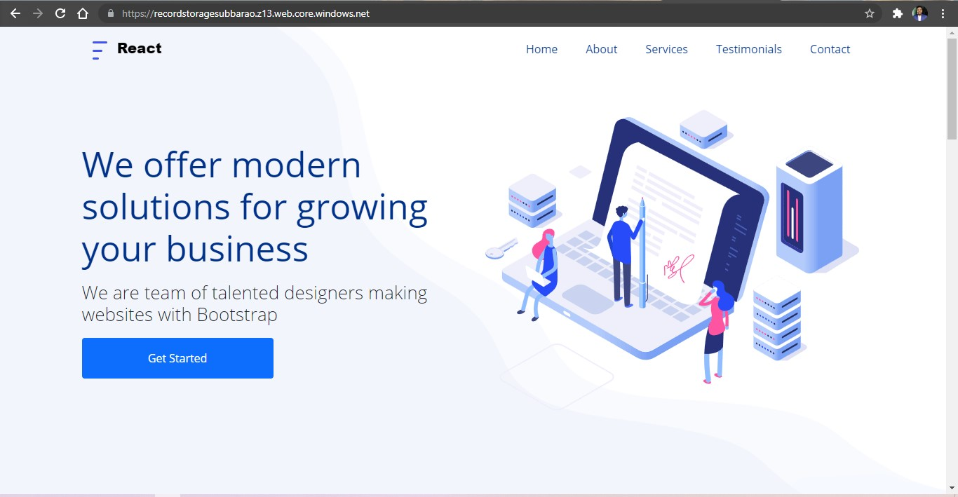

**8.CREATE A SQL STORAGE SERVICE AND PERFORM A BASIC QUERY USING**

**ANY PUBLIC CLOUD SERVICE PROVIDER (AZURE/GCP/AWS) TO**

**DEMONSTRATE DATABASE AS A SERVICE (DAAS)**

**STEP1: GOTO AZURE AND GOTO SQLDATABASE.**

**STEP 02:- Now Create a Sql Databse**

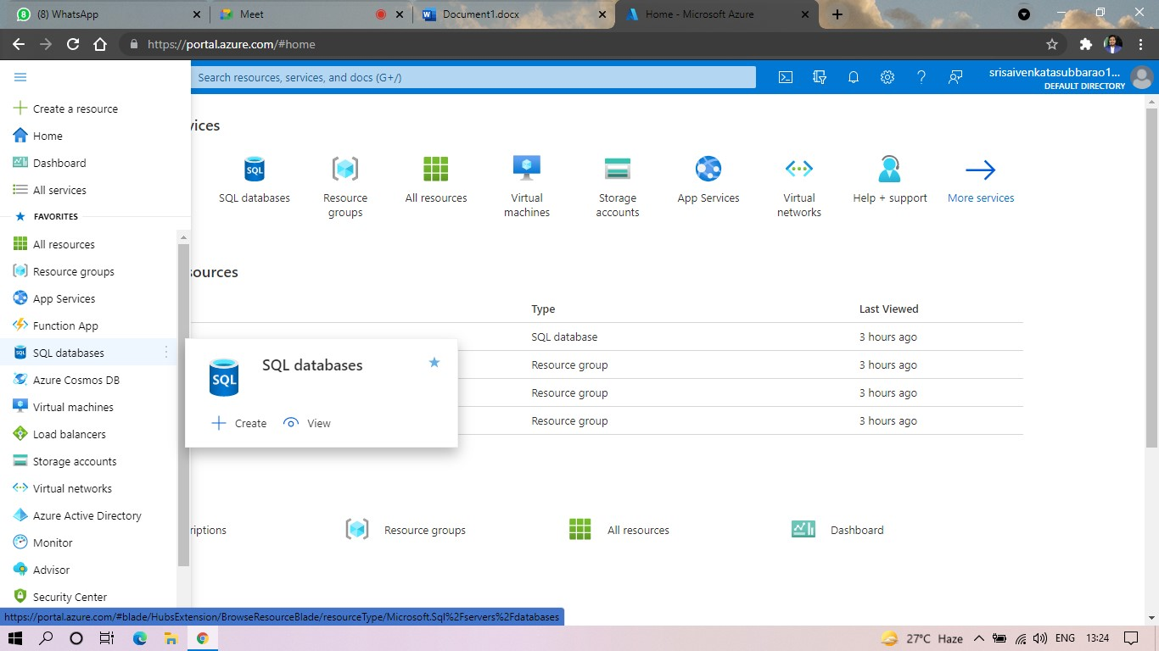

**STEP3: SELECT THE RESOURCE GROUP AND ENTER THE SERVERNAME THAT APPLICABLE.**

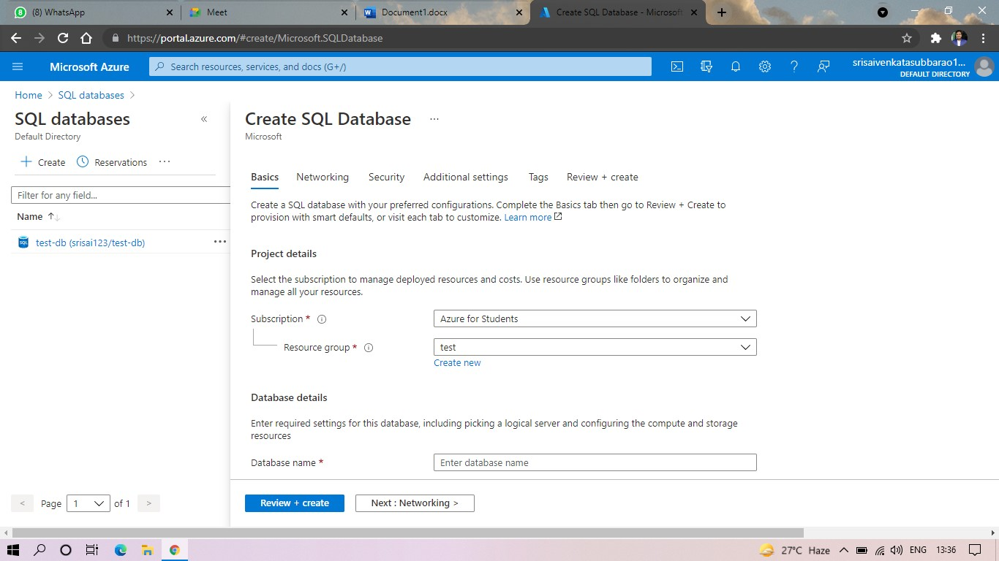

**STEP4: IN NETWORKING SELECT ALLOW AZURE SERVICES AND**

**RESOURCES TO ACCESS THIS SERVER.**

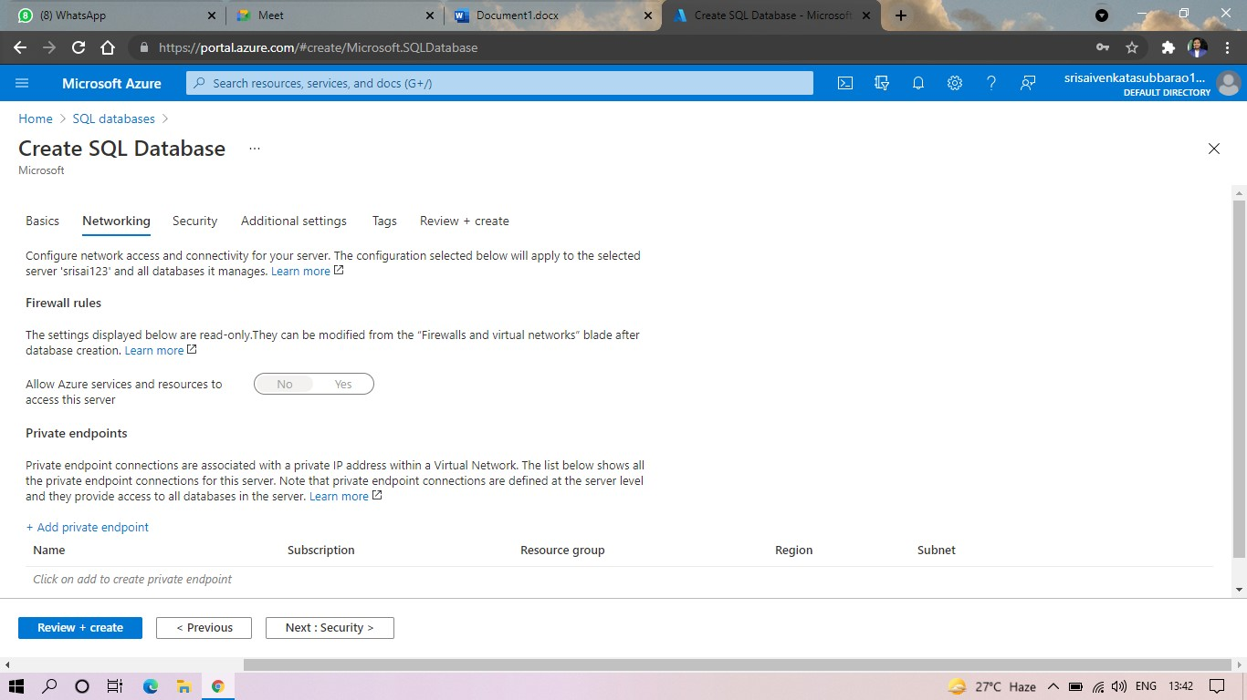

**STEP5: IN ADDITIONAL SETTINGS SELECT SAMPLE.**

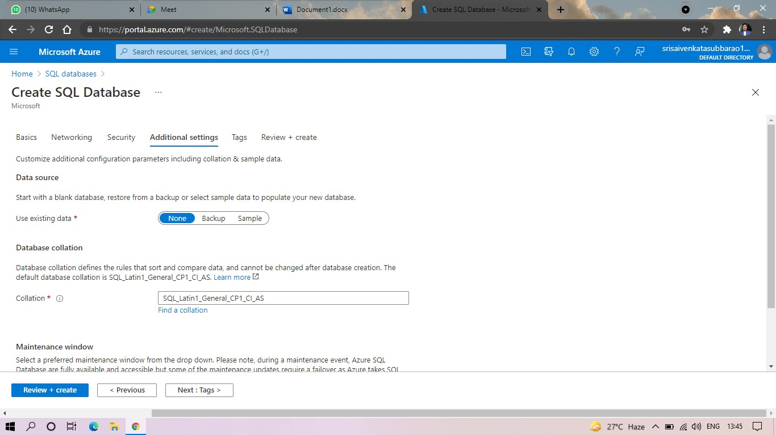

**STEP6:AND THE SQL DATABASE IS DEPLOYED.**

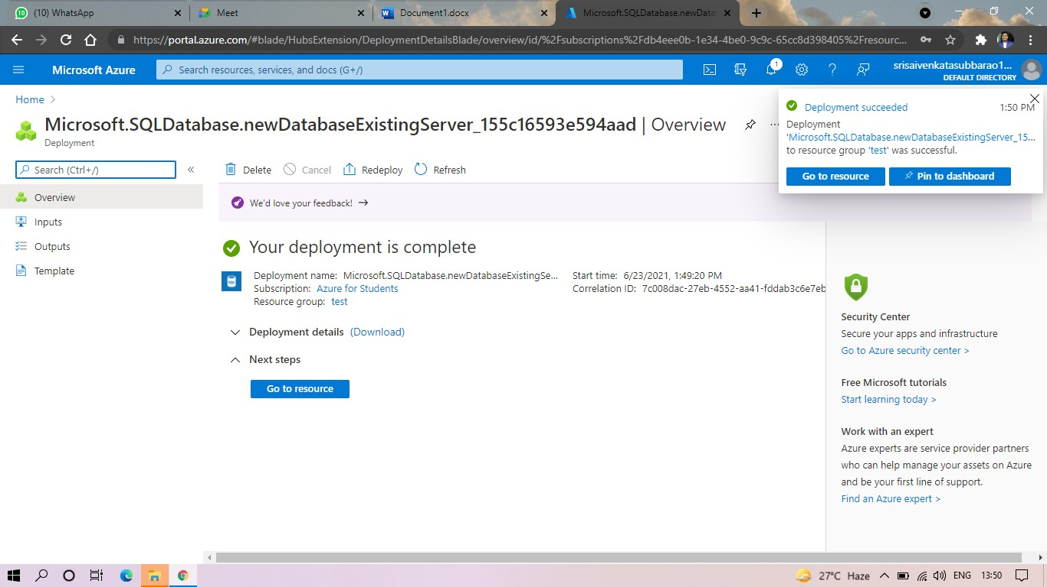

**STEP7:AND NOW GOTO QUERY EDITOR.**

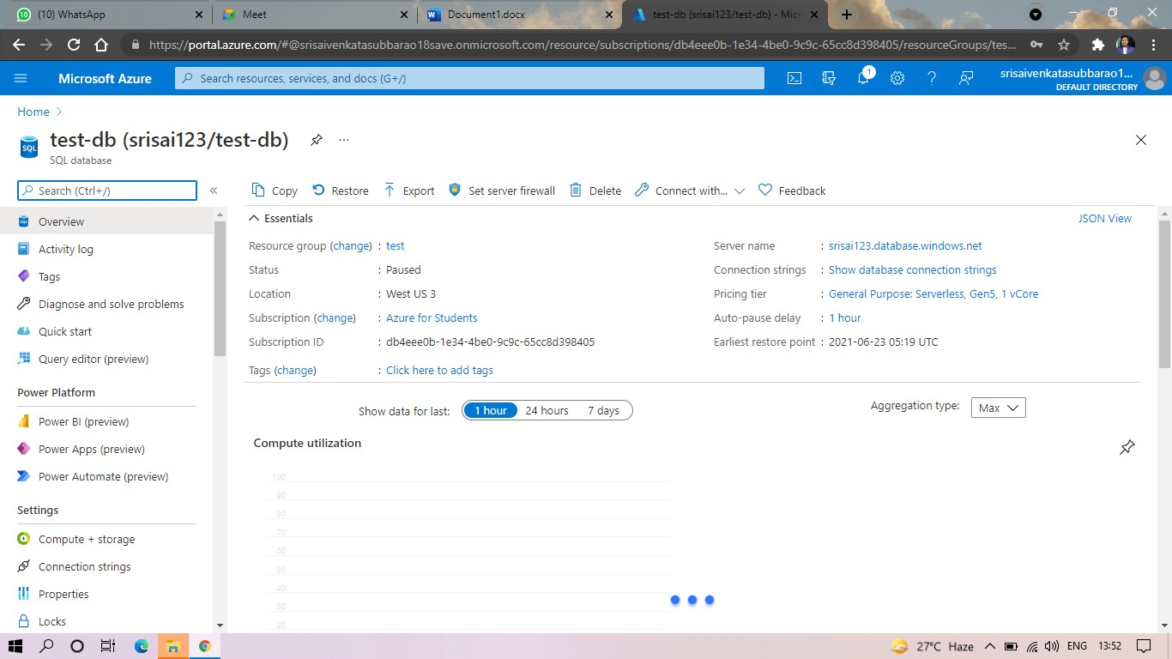

**STEP8:AND NOW AGAIN LOGIN TO THE SQLDATADATABASE**

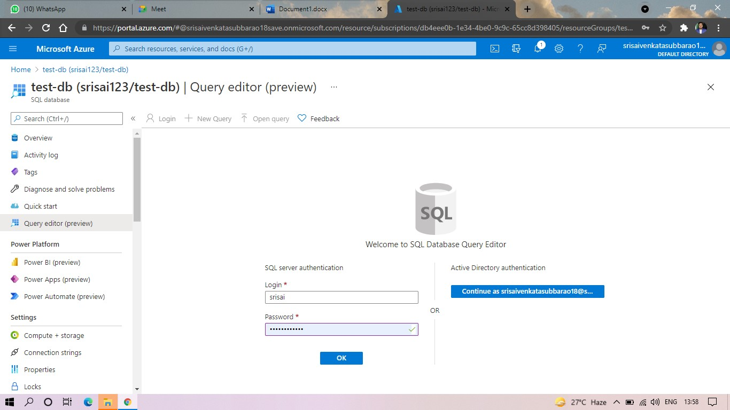

**STEP: AND OUR TABLES WILL SHOWN AND TYPE THE QUERY TO EXCUTED.**

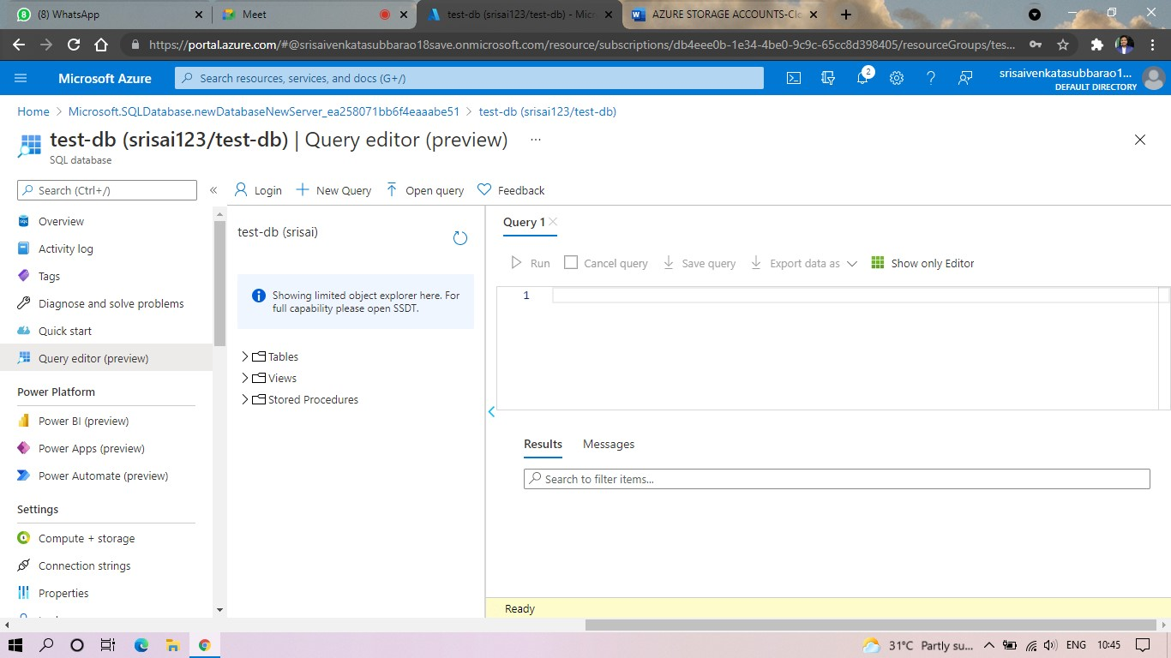

**STEP10: AND OUR OUTPUT IS READY.**

